BURGHCLERE PARISH NEIGHBOURHOOD PLAN
2011 – 2029

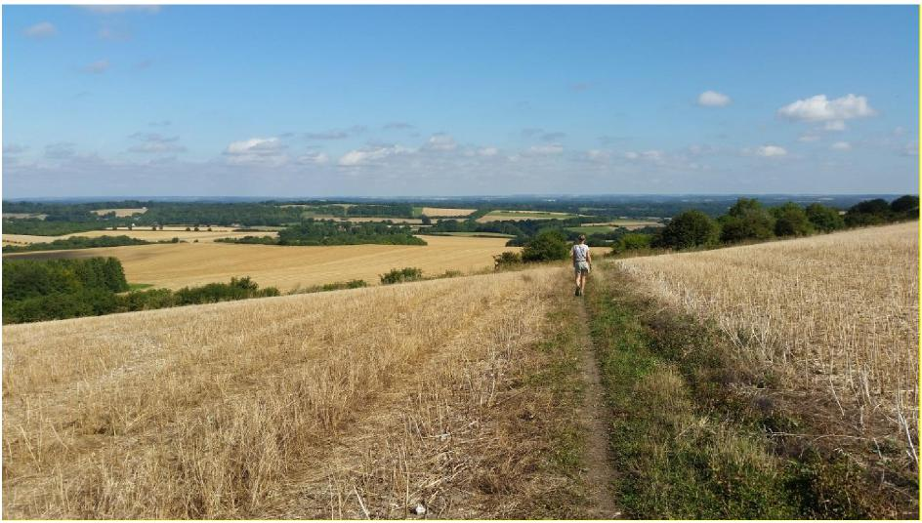
© Richard Carrow
Published by Burghclere Parish Council for examination under the Neighbourhood Planning (General) Regulations 2012 (as amended).
May 2021
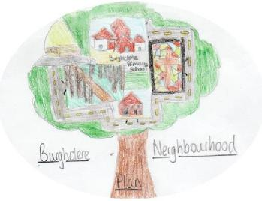

Courtesy of Lottie Baker, Burghclere Primary School
Guide to Reading this Plan
Of necessity, this Neighbourhood Plan is a detailed technical document. The purpose of this page is to explain the structure and help you find your way around the plan.
- Introduction & Background
This section explains the background to the Neighbourhood Plan.
- The Neighbourhood Area
This section details many of the features of the designated area.
- Planning Policy Context
This technical section relates this Plan to the National Planning Policy Framework and the planning policies of Basingstoke & Deane Borough Council.
- Community Views on Planning Issues
This section explains the community involvement that has taken place.
- Vision, Objectives & Land Use Policies
This is the key section. Firstly, it provides a statement on the Neighbourhood Plan Vision and Objectives. It then details Policies which are proposed to address the issues outlined in the Foreword and in Section 4. These Policies are listed on page 6. There are Policy Maps at the back of the plan to which the policies cross reference.
- Implementation
This section explains how the Plan will be implemented and future development guided and managed. It suggests projects which might be supported by the Community Infrastructure Levy, which the Parish Council will have some influence over. Finally, it deals with a number of issues which although relevant are outside the scope of a Neighbourhood Plan.

BURGHCLERE PARISH NEIGHBOURHOOD PLAN
2011 – 2029
May 2021
CONTENTS
Foreword
Preface
List of Policies
- Introduction & Background 7
- The Neighbourhood Area 11
- Planning Policy Context 14
- Community Views on Planning Issues 16
- Vision, Objectives & Land Use Policies 18
- Implementation 48
Policies Map & Insets 50
Schedule of Evidence 53
Appendix 1 - Design Statement 54

FOREWORD

Burghclere is a beautiful rural parish in North Hampshire, popular not only for its proximity to major road and rail links around the South of England but also its wonderful rural setting with Watership Down and North Wessex Downs Area of Outstanding Natural Beauty (AONB). It’s hardly surprising that many people want to live here. Being popular, however, comes at a price and the younger generation struggle to find houses they can afford. Meanwhile, an older generation, who wish to downsize and remain close to friends and family, cannot always find suitable housing for their needs.

The government has granted local communities an opportunity to create plans for future development within the parameters set by local planning authorities. Basingstoke and Deane Borough Council has set parishes housing targets within the Local Plan and, taking advantage of the former to meet the latter, we have developed a Neighbourhood Plan. Unlike the Village Design Statement drawn up in 2002 and on which we have drawn extensively, a neighbourhood plan allows us to decide where and what type of development should take place in our area. As it forms part of the Local Plan it also carries greater ‘weight’ in planning considerations and in particular against speculative planning proposals.

Parishioners have recognised the need to develop a positive, constructive vision for Burghclere and want to take control, as far as possible, over how growth will evolve. The Neighbourhood Plan describes how we can develop and protect the assets and strengths of the parish now and into the future. It has been designed to encourage sustainable development, enabling the parish to achieve the growth required of us, whilst protecting our important heritage and rural character. Specifically, it sets out one site for development in Burghclere and includes policies relating to the style and type of housing development envisaged. There are also policies regarding protection of the landscape, key views and biodiversity, and issues such as tourism and car parking.

We wanted to be ambitious. Indeed, we would wish to go further, particularly in respect of energy efficiency and mitigating the impact of climate change. Currently, existing legislation to which we have to conform does not permit all we had hoped to include. Looking ahead, consequences arising from Covid-19 might affect future development. Basingstoke’s Local Planning Update will result in a new Local Plan in around 3-4 years’ time, at which point we would expect to have to review ours. This will allow us an opportunity to cast a fresh eye over what we want and need to achieve next.

We could not have done this without your support. Heartfelt thanks to all who contributed to its preparation, in particular residents who attended the public meetings, completed questionnaires and visited our stand at village events. Your views have significantly shaped our work. I would like to thank the Neighbourhood Plan Steering Group for all their hard work and valuable insight, the Parish Council for its support, and consultants ONeill Homer, who have contributed high quality professional expertise. We commend this plan to you.
Richard Carrow, Chair, Burghclere Parish Council

PREFACE
Burghclere is a rural parish with a population of about 1,200 people living in over 450 houses spread over an area of approximately 8 square miles.
The built environment of the parish centres around the village of Burghclere itself with a number of dispersed hamlets such as Old Burghclere, Adbury Holt, Whitway and Tothill, and other scattered housing settlements all of which are surrounded by mainly woodland and farmland. The A34 runs through the South and to the West side of the Parish, and the B4640 runs across the North West quadrant. A network of roads connects Burghclere village and its hamlets, some of which are used as ‘rat runs’ for through traffic.
The parish has 57 listed buildings, 10 scheduled monuments and 6 SSSIs. The southern portion of the parish lies within the North West Downs Area of Outstanding Natural Beauty. Several local attractions draw tourists to the region, principal among them being Highclere Castle as well as Sandham Memorial Chapel in Burghclere itself. An extensive network of footpaths and bridleways, together with several commons (Herbert Plantation, Newtown and Earlstone) make the area very popular with walkers, cyclists and horse riders, as well young families who can experience nature on their doorstep.
Amongst those living within the parish are some who have done so all their lives and have strong family connections spanning generations. Others are more recent arrivals, often with young families, who commute to workplaces in London, Newbury or other towns nearby. With its established churches, pubs and Sports Club, older and recent residents alike enjoy a friendly community spirit, from which a variety of other clubs, societies and social networks have sprung. The attractive rural aspect, the quality and character of its built environment, coupled with its proximity to excellent transportation links make Burghclere a very desirable place to live.
Burghclere has grown incrementally over the years while retaining its rural character. We recognise that the parish will continue to grow to meet the demand for housing and the changing demographic shape of the region. Such growth should be sympathetic to the character of the parish, based on local needs and, as far as possible, benefit those who live and work in or have direct connections with the parish.
Through this Neighbourhood Plan we have an opportunity to influence how the parish will develop up to 2029. It now forms part of Basingstoke and Deane Council’s Plan and will consequently inform future development.

LIST OF POLICIES
POLICY # | POLICY | PAGE #
B1 | Burghclere Settlement Boundary | 20
B2 | Land off Harts Lane / Winchester Road | 21
B3 | Residential Garden Land | 25
B4 | Housing mix and tenure | 27
B5 | High Quality Design | 28
B6 | Sustainable Design Standards | 29
B7 | Local Heritage Assets | 30
B8 | Landscape | 30
B9 | Important Views | 31
B10 | Green Infrastructure and Biodiversity | 36
B11 | Local Green Spaces | 41
B12 | Community Facilities | 44
B13 | Tourism | 44
B14 | Car Parking | 45

1. INTRODUCTION & BACKGROUND
1.1 Burghclere Parish Council has prepared a Neighbourhood Plan for the area designated by the local planning authority, Basingstoke & Deane Borough Council, on 26 February 2018. The plan has been prepared in accordance with the Neighbourhood Planning (General) Regulations of 2012 (as amended).
1.2 The area coincides with the parish boundary (Plan A).
1.3 The purpose of the Neighbourhood Plan is to set out a series of planning policies that will be used to determine planning applications in the area in the period to 2029. The Plan will form part of the development plan for the parish, alongside the Basingstoke & Deane Local Plan 2011 – 2029. The Borough Council has recently started the process of reviewing its adopted Local Plan, however the neighbourhood plan is intended to cover the same period as the current Local Plan.
1.4 Neighbourhood Plans provide local communities, like Burghclere, with the chance to manage the quality of development of their areas. Once approved at a referendum, the Plan becomes a statutory part of the development plan for the area and will carry significant weight in how planning applications are decided. Plans must therefore contain only land use planning policies that can be used for this purpose. This often means that there are important issues of interest to the local community that cannot be addressed in a Plan if they are not directly related to planning.
1.5 Although there is considerable scope for the local community to decide on its planning policies, Neighbourhood Plans must meet certain ‘basic conditions’ before they come into force. In essence, the basic conditions are:
- Having regard to national policies and advice contained in guidance issued by the Secretary of State, that it is appropriate to make the neighbourhood development plan;
- That the making of the neighbourhood development plan contributes to the achievement of sustainable development;
- That the making of the neighbourhood development plan is in general conformity with the strategic policies contained in the development plan for the area – in this case Basingstoke and Deane Borough Council (or any part of that area);
- The making of the neighbourhood development plan does not breach, and is otherwise compatible with, EU obligations;
- Prescribed conditions are met in relation to the Plan and prescribed matters have been complied with in connection with the proposal for the neighbourhood plan. Burghclere Parish Council confirms there are no prescribed matters in relation to the Plan, and
- The Conservation of Habitats and Species and Planning (Various Amendments) (England and Wales) Regulations 2018, which came into force on 28 December 2018 added a further Basic Condition. The making od the neighbourhood development plan does not breach the requirements of Chapter 8 of Part 6 of the Conservation of Habitats and Species Regulations 2017(7).
1.6 The Parish Council consulted on a Pre-Submission Plan 17 September – 29 October 2019. Comments were received from local people and from some statutory bodies and landowners. It is clear there is majority support from the local community for the Plan, but a few changes have been necessary to improve clarity and application of policy wording that ensures the Plan meets the Basic Conditions. A separate Consultation Statement sets out those changes and describes the overall process of formal and informal consultations carried out during the process.
The Referendum Plan
1.7 The Parish Council has demonstrated to an independent examiner that it has successfully engaged with the local community in preparing the Plan. The examiner is satisfied that it has, and considers the Plan meets the basic conditions and other statutory requirements.
1.8 A local referendum on the Plan was held on 6 May 2021 asking registered voters: “Do you want B&DBC to use the Burghclere Parish Neighbourhood Plan to help it decide planning applications in the Burghclere Parish Neighbourhood Area?”
1.9 The result of the referendum on a 46.5% turnout was announced on 7 May 2021 with 366 in favour and 81 against, giving an overall margin of approval of 81.8%. From this moment the Plan forms part of the local Development Plan.

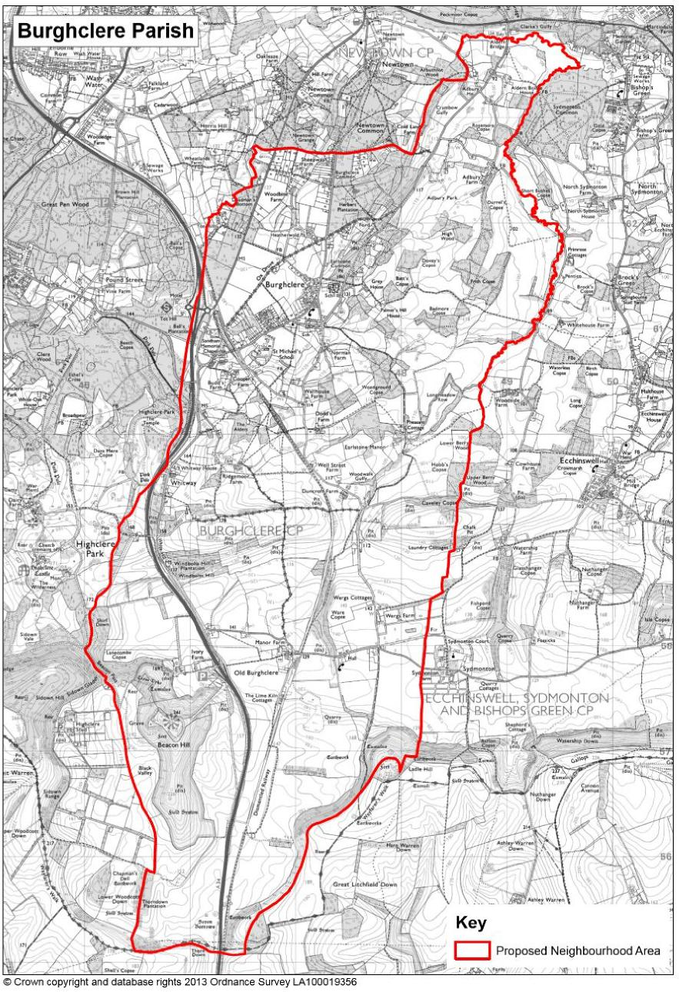
Plan A: Designated Neighbourhood Area

Strategic Environmental Assessment (SEA) & the Habitats Regulations
1.8 Basingstoke & Deane Borough Council confirmed in its screening opinion of November 2018 that a Strategic Environmental Assessment (SEA) is considered to be required to accompany the Burghclere Neighbourhood Plan in accordance with the Environmental Assessment of Plans & Programmes Regulations 2004. A Draft Sustainability Appraisal Report (incorporating SEA) was consulted on alongside the Pre-Submission version of the Plan. This follows a scoping exercise that involved consultations with the statutory bodies and has resulted in a framework of relevant environmental, social and economic objectives being agreed to measure the attributes of the Plan. The final version of the SA/SEA report has been revised to take account of the comments received and is published separately alongside this Submission version of the Plan.
1.9 The screening opinion also confirmed that the Plan will not need to be subject to a Habitats Regulations Assessment in accordance with the Conservation of Habitats and Species Regulations 2010 (as amended).

2. THE NEIGHBOURHOOD AREA
2.1 Burghclere Parish is oblong in shape along its north-south axis and is located to the south of Newbury and Greenham Common. While Greenham Common has a defence related past, a growing Business Park has been developed on the built-up area of the site, and the remaining bunkers are used in film making. The historic market town of Newbury provides Burghclere with employment, shopping and other facilities and services.
2.2 The western edge and south of the parish lies within the North Wessex Downs Area of Outstanding Natural Beauty (AONB) (see Plan B below) with extensive views to Ladle Hill and Beacon Hill to the south and south east. To the north is flatter terrain and extensive parcels of ancient woodland. The northern boundary runs along the River Enborne and the parish is surrounded by other settlements such as Whitchurch to the south, Highclere to the west, and Ecchinswell and Kingsclere to the east.
Plan B: Environmental constraints in Burghclere
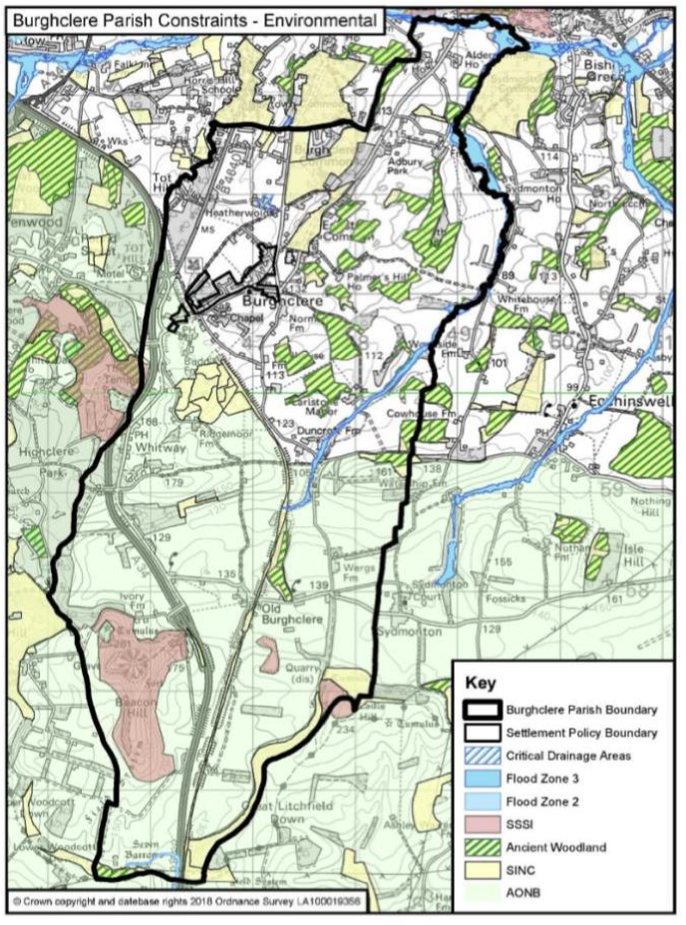

2.3 The A34 runs north-south along the western side the parish, as does the disused Didcot to Southampton railway line. The Parish had two stations; Burghclere station at Old Burghclere and Highclere station in the village of Burghclere. With the railway line came the expansion of the parish.
2.4 The parish has a long history. There are Bronze Age barrows to the south of Beacon Hill, where there was an Iron Age settlement. There is mention of a church at Burghclere in the Domesday survey. It is thought that the parish developed at the southern end with the mediaeval village at Old Burghclere. Following the Black Death this was deserted and is now only visible as irregularities in the ground.
2.5 While the parish remains predominately rural, there is a distinctive change in landscape typology between the flatter terrain in the north and the highly visible landscape features in the south - Beacon Hill, Ladle Hill and Watership Down. Over the centuries the population has moved from the high chalk in the south to the lower lying areas in the north.
2.6 To the north is the village of Burghclere, smaller low-density hamlets and pockets of ancient woodland. The spread of development over the years has created several distinct settlement areas in addition to the main village of Burghclere and Old Burghclere. The population of the whole Parish was recorded as 1,152 and 450 dwellings in the Census 2011.
2.7 Whitway/West Street lies in the west of the parish, and Tothill, Sheepwash Lane, Heatherwold, Adbury Holt and Aldern Bridge in the north. The parish also contains a number of dispersed countryside estates such as Adbury Park Farm. While these settlements have very limited services, Old Burghclere retains a successful restaurant. To its east is part of Wergs Farm that runs over the parish boundary and forms part of Sydmonton Court Estate. Whitway also retains a successful pub. These smaller settlements identify themselves as part of the Burghclere community.
2.8 The parish has four schools, each having an extensive catchment area which is typical of rural areas, these are; Burghclere Primary School, Clere School (a Secondary School but with no sixth form), Burghclere Pre-School, and the independent St Michael’s School.
2.9 There are 57 listed buildings in the Parish, including the Grade I barn to the south west of the Grade II* Manor House, and the Grade I Church of All Saints at Old Burghclere and the Grade II* Earlstone Manor. Five of the scheduled ancient monuments known as the Seven Burrows lie to the north and east of Thorn Down, four further scheduled ancient monuments forming part of Beacon Hill and Ladle Hill. The Grade II* Earlstone Manor lies between Old Burghclere and the village of Burghclere. The Grade I Sandham Memorial Chapel, a National Trust property, lies in the village of Burghclere. A very small part of the Historic Park and Garden of Highclere Park lies within the parish, with the majority lying to the south west, outside the parish.
2.10 Part of the parish along the northern boundary with the River Enborne and its tributaries lies within Flood Zone 3, an area with a high probability of flooding. There is an extensive Mineral Safeguarding Area around the village of Burghclere (see Plan C overleaf).

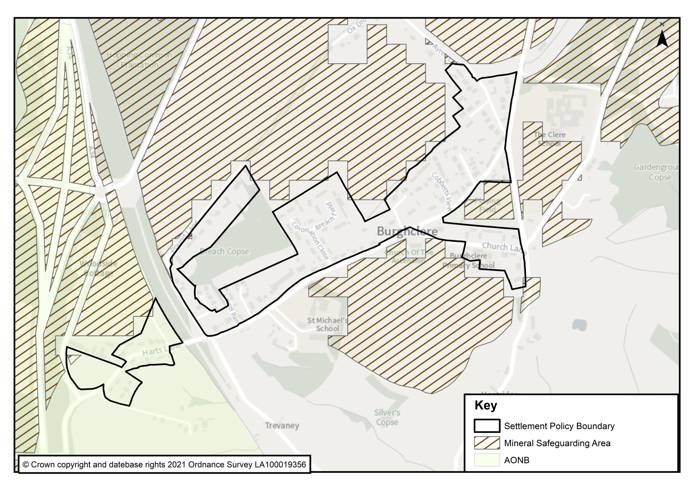

Plan C: Mineral Safeguarding Area

3. PLANNING POLICY CONTEXT
3.1 The parish lies within the Basingstoke & Deane Borough area in the county of Hampshire.
National Planning Policy
3.2 The latest National Planning Policy Framework (NPPF) published by the Government in 2019 is an important guide in the preparation of local plans and neighbourhood plans. The following paragraphs of the NPPF 2019 are considered especially relevant:
- Housing Requirement (§65)
- Rural Housing (§77)
- Rural Economy (§83)
- Healthy and Safe Communities (§91)
- Community Facilities (§92)
- Local Green Space (§99 - §101)
- High Quality Design (§125)
- The Natural Environment (§170 - §172)
- Biodiversity (§174)
- The Historic Environment (§185)
Strategic Planning Policy
3.3 The Neighbourhood Plan must be in general conformity with the strategic policies of the development plan. The development plan primarily comprises the
Basingstoke & Deane Local Plan 2011 – 2029 adopted in May 2016. Its key policies applying to the Parish are:
- Policy SS1 Scale and Distribution of New Housing – defines a settlement boundary for Burghclere (see Plan D);
- Policy SS5 Neighbourhood Plans – requires Burghclere to provide 10 dwellings over the plan period.
3.4 There are also a wide range of development management policies:
- Policy CN3 Housing Mix for Market Housing – requires market housing to be made up of type and size that addresses local requirements;
- Policy CN8 Community, Leisure and Cultural Facilities – seeking to protect and enhance community facilities;
- Policy EM1 Landscape – reflecting the national importance of the North Wessex Downs AONB and its setting and requiring proposals to adhere to criteria set out in the North Wessex Downs AONB Management Plan;
- Policy EM4 Biodiversity, Geodiversity and Nature Conservation – seeking to protect and enhance biodiversity;
- Policy EM5 Green Infrastructure – seeking to protect and enhance green infrastructure assets;

- Policy EM10 Delivering High Quality Development – setting out criteria to secure a robust design-led approach;
- Policy EM11 The Historic Environment – seeking to conserve and enhance the quality of the historic environment;
- Policy EP4 Rural Economy – supporting economic uses in the countryside;
- Policy EP5 Rural tourism – supporting tourism development in the countryside.
3.5 The Hampshire County Council Minerals and Waste Plan 2030 adopted in October 2013 also forms part of the development plan. A key policy applying in Burghclere is Policy 15 Safeguarding - mineral resources which defines several Minerals Safeguarding Areas (MSA) in the Parish. These are areas where an additional test will be applied in order that proven resources are not needlessly sterilised by non-mineral development, whilst not creating a presumption that resources defined will be worked, and where appropriate regeneration can be facilitated (see Plan C).
3.6 There are also ‘made’ neighbourhood plans in the vicinity which form part of the development plan, notably at Kingsclere. None contain policies that are of direct relevance to this Neighbourhood Plan.
3.7 In areas within the North Wessex Downs AONB the Development Policies (DE01 – DE23) of the AONB Management Plan 2019 – 2024 should also be given full consideration.
3.8 Recent developments in Burghclere include six dwellings at the Pound Lane (Sandham Place) development and as Burghclere is required to provide 10 dwellings over the plan period, the village would only need to identify 4 more. However, the threshold for development adjacent to the Policy Settlement Boundary to count towards the required number of housing is 5.
3.9 In addition to this, the Neighbourhood Plan is being prepared prior to a review of the adopted Local Plan, details of which have not yet been published. However, it is anticipated that Basingstoke and Deane will have to provide additional homes to that planned for in the adopted Local Plan.
.
4. COMMUNITY VIEWS ON PLANNING ISSUES
4.1 Two informal consultations have been conducted with residents. The first was a ‘Have Your Say’ afternoon on 6th April 2018 followed by a presentation on neighbourhood planning by a Planning Officer from B&DBC and a Q&A session afterwards. Over 50 attended during the afternoon and over 70 the evening presentation. Concerns raised at the Q&A session included loss of village rural character, where houses might be built, support for smaller affordable homes not big mansions and whether the local council might override local opinion. The second took place during two Drop In sessions at the Portal Hall in December 2018. Over 80 attended and 53 questionnaires were returned.
4.2 There was significant support for affordable housing for first time buyers, suitable housing for older people to live independently, those with additional needs and for local people to upsize or downsize. Residents were also asked to indicate their preferred sites and least favoured sites and results collated ranking the sites by preference. The site preferred was the parcel of land at the SW end of the village (Site A or BUR 006 in the 2018 SHELAA). There was significant support for designating green spaces and protecting views, and for tourism and additional local business, although somewhat reduced.
4.3 The following broad conclusions emerged:
- There was strong support for the proposed (10-15) housing numbers. Among the comments was concern that some of the sites could accommodate more than this number. Several thought that more houses might be needed.
- A large proportion felt that the mix of criteria selected was right. A few thought sites should also encourage walking to school.
- Of the 4 sites that best met the criteria, a significant majority considered Site A (BUR006) best met the criteria, followed by Sites F, H & I. A number noted that Sites A and F are in the AONB and at the entrance of the village from the South. Some concern was raised about site sizes (in particular F & H). Asked whether any of the excluded sites were more suitable, over half said no.
- There was substantial support for the use of Parish land to be used for affordable housing for local people.
- A significant majority supported the proposed mix of design, heritage and key views policies to preserve and enhance Burghclere’s rural character.
- There was significant agreement for the proposals that protect local green spaces, green infrastructure and community facilities and allow for future improvement.
- Support for business policies and a rural business hub was expressed. A few suggested a shop or café might be considered.
- The proposed policy on tourism gained similar backing and over half thought that the parking and traffic policies were viable. Views varied as to what to do about traffic and parking; a number thought the Primary School needed more parking, but there was no unanimity on a solution.
4.4 Consultation with local schools, businesses, landowners and other stakeholders took place between February and June 2019 and the outcome of this consultation is considered to be reflected in the plan and its policies along with the views of the local community from previous consultations.
4.5 Paragraph 1.7 of this Plan summarises the outcome of the Pre-Submission Plan consultation. A more detailed account is set out in the Consultation Statement which accompanies this plan.
4.6. On 8 July 2019 a land promoter, Falcon Developments, submitted an outline planning application for 35 houses on Site B/BUR003 only 4 days after notification that B&DBC had lost its 5-year land supply. This meant that Policy SS1of the Local Plan was superseded by Paragraph 11 of the NPPF (the presumption in favour of sustainable development). After a public meeting on 18 September 2019, at which all 109 parishioners present bar one abstention voted against Falcon’s application, the Parish Council submitted an objection to B&DBC noting, inter alia, that it undermined the principles of neighbourhood planning by being premature to the Burghclere Parish Neighbourhood Plan. B&DBC rejected the application in November 2019, which Falcon Developments appealed. The Planning Inspectorate held a Hearing on 3 December 2020 with all interested parties and after due consideration dismissed the appeal.

5. VISION, OBJECTIVES & LAND USE POLICIES
Vision
  - The vision of the neighbourhood area in 2029 is:
“Burghclere village has grown whilst retaining its special rural qualities. Growth has not undermined the landscape and has preserved the essential character of the parish, village and outlying hamlets, and important views into and from the countryside.
New homes have helped address local need and sustain the demand for cherished community facilities – the Portal Hall, recreation ground and the local schools.
The design of new homes on the edge of and on infill sites within the village respect local character. There is a wider range of entry level housing types that enable younger people to find homes and older households to downsize. There are also now more affordable homes in the village.
Technological changes have resulted in increased use of fuel-efficient and electric modes of transport, benefiting the environment. These also allow more working from home rather than reliance on commuting. The growth of new micro-businesses throughout the parish means the parish is more self-contained.
Recognition of the benefits of rural biodiversity has enhanced the connectivity between the village and the countryside. The development of the parish has not only avoided harm to its biodiversity but has also helped create new ecological value.
The tourism potential of the area has been realised and has led to new local employment opportunities. Beacon Hill, Sandham Memorial Chapel and activities at the Recreation Ground continue to thrive. There are improved village car parking facilities.”
Objectives
  - The key objectives of the Neighbourhood Plan are:
Housing:
- To help meet housing needs by supporting the delivery of new housing in accordance with B&DBC Policy SS5. (Polices B1& 2)
- To help meet the need for smaller homes by securing a more appropriate mix of housing in new developments (Policy B4)
- To ensure any new housing is built on sites and at densities that would not harm the prevailing character of the area in which it is set or the amenity of nearby properties. (Policies B5, 6, 8, 9, 13)
Design, Heritage and Landscape
- To ensure all new development respects the particular character of the area in which it takes place in terms of design, layout, materials and sustainability. (Policies B3, 5 & 6)
- To protect and enhance the parish’s heritage, including the North Wessex Downs AONB, listed buildings and other locally important buildings and structures across the parish. (Policies B5, 7 & 8)
Environment
- To protect and enhance the most valued open spaces for the use of the community within and adjacent to the settlement policy boundary. (Policy B11)
- To maintain and improve biodiversity and the quality of the natural environment. (Policy B10)
Business & Tourism
- To support the local economy and encourage opportunities for smaller businesses to grow and develop in appropriate locations across the parish including the potential for a rural business hub and working from home. (Policy B2)
- To support and encourage tourist attractions without detriment to the amenity of the village and parish. (Policy B13)
Parking
- To ensure appropriate parking provision is made within any new development and that better parking is provided within Burghclere village. (Policy B14)
Land Use Policies
  - The following policies relate to the development and use of land in the designated Neighbourhood Area of Burghclere. They focus on specific planning matters that are of greatest interest to the local community, especially in seeking to accommodate its housing requirement figure and securing high quality design.

  - There are many parts of the Parish that are not affected by these policies and there are many other policy matters that have been left to the Local Plan to cover. This has avoided unnecessary repetition of policies between the two plans, though they have a mutual, helpful inter-dependence.

  - Each policy is numbered and titled, and it is shown in bold italics. Where necessary, the area to which it will apply is shown on the Policies Map attached to the document. After each policy is some supporting text that explains the purpose of the policy, how it will be applied and, where helpful, how it relates to other development plan policies.

Policy B1: Burghclere Settlement Boundary (BSB)
The Neighbourhood Plan defines a settlement boundary at Burghclere, as shown on the Policies Map.
Development proposals within the defined settlement boundary will be supported, provided they accord with policies of the development plan.

Outside the Settlement Boundary is considered to be countryside where other development plan policies and national policies apply.
  - The policy defines the extent of the Burghclere Settlement Boundary (BSB) for the purpose of applying Local Plan Policy SS1 – Scale and Distribution of New Housing which sets out the principles of development within settlement boundaries and the surrounding countryside. A map showing the original Settlement Policy Boundary and new Settlement Boundary is at Plan D. Maps displayed subsequently will show the new Settlement Boundary.

  - Burghclere Village is surrounded by sensitive landscape that seeks to be protected from larger scale developments threatening the rural character of the area. It is therefore crucial that new developments remain in and around the current built-up area, to minimize the impact they would have on the landscape.

  - The policy sets the spatial strategy for the neighbourhood plan. Its objectives are to allow sustainable growth to meet its local housing requirement figure, an additional quantum of housing providing flexibility for future housing growth, over the Plan period while also protecting the integrity of the rural character of the village. The revised settlement boundary therefore accommodates the site allocation proposed by Policy B2 which will deliver at least 15 new homes and will therefore make a positive contribution to meeting housing requirements in the Borough in this plan period and beyond.

  - The boundary is principally derived from the defined Settlement Policy Boundary provided for by Policy SS1. Its purpose is to clearly translate the BSB in the adopted Local Plan boundary drawn to incorporate the site allocation of Policy B2 and the 6 dwellings recently completed at Sandham House off Pound Lane. It therefore updates the settlement boundary defined on the Policies Map of the Local Plan. The Policy also allows for the continuing growth of the village through suitable infill sites. The suitability of sites for infill development will be judged against the design policies of the development plan.
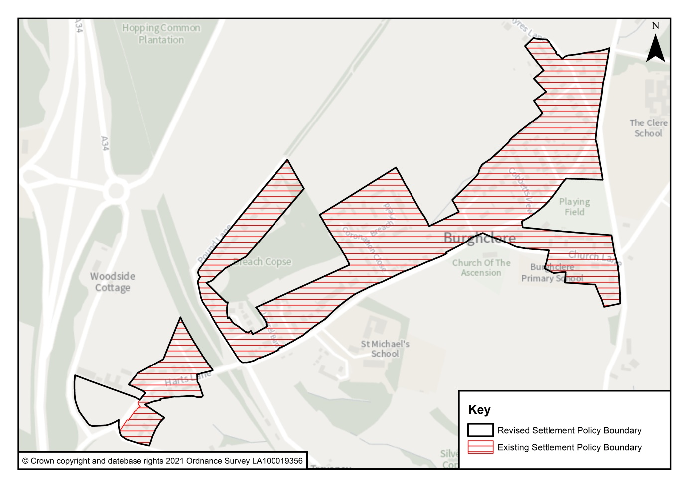
Plan D: Existing and revised Burghclere Settlement Boundary (BSB)
Policy B2: Land off Harts Lane / Winchester Road
The Neighbourhood Plan allocates 0.89 Ha of land north of Harts Lane for a mix of residential, employment and blue/green infrastructure uses as shown on the Policies Map. Development proposals will be supported, provided the following key requirements are met:
- The residential scheme delivers at least 15 dwellings comprising a mix of open market and affordable homes in accordance with Local Plan policies with an emphasis on 2 and 3 bed homes suitable for first time buyers, those looking to rent their first home, retired estate workers and downsizers;
- The employment scheme consists of a single storey B1 ’flexible workspace’ of about 150m2 forming a ‘rural business hub;
- The provision of informal and formal recreation space to the Basingstoke and Deane Borough Council’s adopted standards, including a Local Equipped Area for Play (LEAP), if there is a proven need, which is accessible to children from the village;
- A landscape strategy is prepared, and the layout and heights of buildings have full regard to the Local Plan policy requirements, the location of the land within the North Wessex Downs AONB and the setting of heritage assets;
- Mature trees and hedgerows forming the site boundary are retained unless their removal is essential;
- A Noise Impact Assessment is prepared and where noise mitigation is recommended this is implemented in accordance with specifications to be agreed with the Local Authority;
- A biodiversity strategy is prepared in accordance with the development plan, which delivers a ‘net gain’ in overall biodiversity value on site; and a drainage strategy is prepared and agreed with the Lead Local Flood Authority;
- Pedestrian and cycling access is provided off Harts Lane to a specification to be agreed with the Highways Authority;
- Vehicle access is made from Harts Lane in a location and of a type which reflects the rural setting to be agreed with the Highways Authority;
- Layout, character and materials will reflect the local rural character and settlement edge setting of the site and external spaces will be designed to take account of solar orientation for amenity and sustainability purposes;
- The layout will be designed to create a sense of arrival within the scheme and provide a community focus for residents and encourage pedestrian and cycle links to the village;
- Building form and roofscape will be designed to be sympathetic to the site’s characteristics and to respect the AONB setting; and
- The layout has regard to the need for utility providers to access infrastructure on the land for future maintenance and upgrading.

  - The policy allocates land for a mixed-use scheme north of Harts Lane. The settlement boundary of Policy B1 has been modified to incorporate the site and the scheme is expected to deliver at least 15 dwellings to meet the residual housing requirements of Policy SS5, as well as making provision for an additional quantum of housing to meet additional local needs and provide the village with the protection of §14 of the NPPF.
  - The site lies just within the North Wessex Downs AONB between the A34 Newbury by-pass and the AONB boundary. See Plan E. The Parish Council are aware of their obligations under the Countryside and Rights of Way Act (CROW Act 2000 Section 85) and the ‘great weight’ attached to conserving and enhancing landscape and scenic beauty in Areas of Outstanding Natural Beauty. The policy requirements seek to ensure that the potential for adverse landscape impacts are successfully mitigated. A Landscape and Visual Appraisal concludes the site is of low-medium value both intrinsically and as a contributor to the character of its setting, given its current condition as an uncultivated field and high boundary vegetation adjacent to the urbanising feature of the A34. The appraisal also confirms there is limited ‘intervisibility’ between the site and the main body of the AONB.
  - While the scale of the proposed allocation is limited, the socio-economic benefits of the scheme are considered to provide the ‘exceptional circumstances’ as required by paragraph 172 of the NPPF to outweigh any harm to the designated landscape. The AONB Background Paper (in the evidence base) indicates that the proposal is not considered to be ‘Major Development’. This judgment is, however, a matter for the Local Planning Authority to conclude as decision-maker. BDBC has advised that in their opinion the allocation does not meet the test of ‘Major Development’. The scale of development proposed and the setting of the allocation (severed from the main body of the AONB by the A34) is not considered to significantly affect the character and appearance of the North Wessex Downs AONB given the particular characteristics of the site.
  - The policy sets out a series of key development principles to ensure the potential effects of development are addressed and to ensure the scheme is of high quality and delivers clear community benefits. The National Planning Policy Framework expands upon the fundamental principles of good design to define what is expected for well-designed places and explain how planning policies and decisions should support this. The policy is drafted to ensure there is sufficient clarity to enable the policy to inform Development Management considerations and to avoid ambiguity; the development principles outlined in the policy provide such clarity.
  - The supporting evidence indicates that it is possible to avoid or mitigate any significant adverse environmental effects by ensuring compliance with the requirements of the policy. Although not a specific policy requirement the land owner/developer is encouraged to engage with the Parish Council and the community in the preparation of a design brief prior to the submission of any application. This responds to the heightened emphasis placed on design standards and design quality now anticipated through the Written Ministerial Statement dated 1st October 2019 which accompanied the publication of the National Design Guide and by paragraphs 124 and 130 of the NPPF.
  - The policy also encourages a 'co-design' approach is undertaken prior to a planning application being submitted as advocated by NPPF 124 and paragraph 17 of the National Design Guide. This is to ensure the scheme retains a sense of community 'ownership' as described by policy L3 (paragraph 160) of the Guide.
  - An objective of the Neighbourhood Plan includes meeting the need for smaller homes and the policy therefore seeks to encourage an emphasis on homes suitable for those looking to buy or rent their first home, retired estate workers and downsizers. No conclusion has yet been reached, but the policy requires consideration to be given to deliver a proportion of the homes in this way in line with policy B5 and to afford opportunities for people with a local connection to gain access to local housing to meet their needs. Moreover, the delivery of affordable homes delivered through a Community Land Trust (CLT) would be supported by the parish council.
  - The allocation also includes the formation of a rural business hub. The Local Plan supports the continued expansion of traditional rural enterprises such as rural crafts, tourism / day visitors and rural leisure pursuits. The BDBC Economic Needs Assessment (Feb 2018) confirms that while the vast majority of the existing employment floorspace stock and recent employment related developments have taken place in Basingstoke town, business space is also available in the rest of the predominantly rural parts of the Borough which provide opportunities for local jobs. Business floorspace in Burghclere, however, is in short supply and floorspace at Beacon House adjacent to this site is fully occupied. The Economic Needs Assessment confirms (paragraph 6.85) that the demand for incremental small-scale growth in flexible B type uses of a modest scale (under 500 sq. m) will continue into the future and small-scale demand could be fostered at the neighbourhood scale as proposed by this policy.
  - The approach taken in the policy avoids the vagaries of leaving such a requirement to be dealt with as a development management matter (which as the Economic Needs Assessment also confirms is a process that small scale enterprises are unlikely to engage with) while delivering wider community benefits for Burghclere by providing opportunities for homeworkers to expand their business activities in the village. This in turn will help to reduce the need to travel to employment further afield. The 2011 census indicates about 15% of residents work from home and the average distance travelled to work by residents of the Parish is 24.7km of which just under 70% of journeys are by car. (Source: Census 2011 table QS701 & 702EW).
  - If no progress is being made to secure the operation of the Business Hub, then consideration will be given to how this use may be secured. This may include consideration by the Parish Council of accepting operational responsibility/ownership of the Hub for employment purposes or wider community functions. However, the Rural Business Hub is based on an existing proven and viable model in a nearby Parish. The operator of that Hub has indicated the proposal is of a size and location to meet a demand in the local area and has confirmed their interest in taking the Hub forward as a commercial operation. Survey work to scope demand has revealed 88% of 40 respondents would anticipate using such a facility ranging from full-time to several times a year. The availability of a meeting room drew significant interest and one that could be put to other purposes such as therapy, craft workshops etc. 77% of respondents were from Burghclere and surrounding districts demonstrating support for this scheme.
  - The modest scale and single storey requirement of the building is to ensure such a proposal remains both viable and accessible by reducing the costs associated with DDA compliance. As such the policy is a deliverable response to the aspirational requirements set out in policies EP4 and 5 of the adopted Local Plan and paragraphs 83 and 84 of the NPPF.
  - The policy requirements reflect the development brief provided to the land promoter, who have confirmed the policy and the development principles it contains are deliverable and that there are no constraints that would impact on scheme viability.
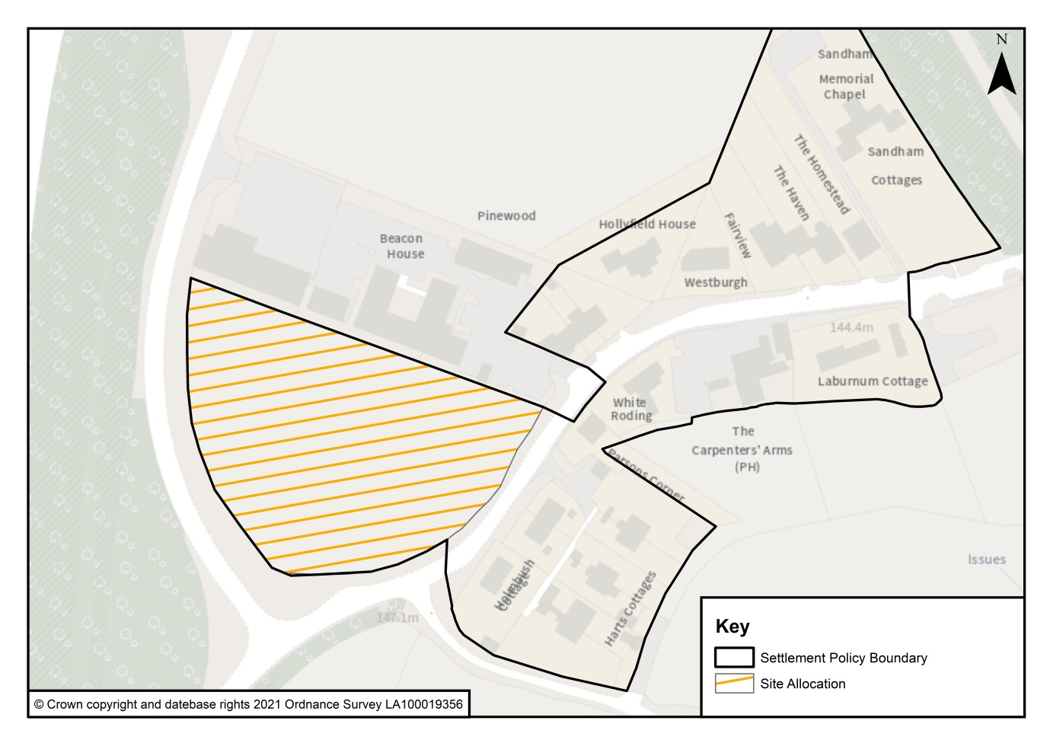
Plan E: allocated site and revised SPB

  - The work on the Vision and Objectives, and the Sustainability Appraisal, provides the basis for how the village can evolve in a sustainable way in the coming years. A number of objectives were generated to develop a clear spatial understanding of the neighbourhood area. The most important principle is that future growth must continue to lie adjacent to the defined settlement boundary to be in ‘general conformity’ with the development plan. The other spatial principles comprise protecting the integrity of the rural character of the village; minimising local traffic congestion; utilising access to and from existing infrastructure; and having convenient access to the strategic road and rail network. This has culminated in the proposed housing site allocation.

  - In the December 2018 consultation, the community indicated their support for this approach, including a majority who supported the proposed site allocation on land off Harts Lane / Winchester Road. The Borough Council has confirmed that this allocation will meet in full the housing requirement figure for the neighbourhood area up to 2029 (as per paragraph 65 of the NPPF).
Policy B3: Residential Garden Land
Where planning permission is required, development proposals on residential garden land within the Settlement Boundary will be supported subject to the following criteria:

- they maintain the prevailing character and appearance of buildings in their immediate locality;
- they reflect the scale, mass, design and layout of existing residential dwellings;
- they safeguard the amenities of adjacent residential dwellings and their curtilages;
- they provide off-street parking to development plan standards;
- they have appropriate and safe access to the highway network; and
- any loss of biodiversity value on the site will be fully mitigated, and measures to enhance biodiversity through habitat creation or improvement are incorporated.
  - This policy sets out the Plan’s approach to potential development on residential garden land (RGL).
  - The development plan is silent on policy to resist inappropriate development on RGL. The policy therefore is intended to reflect NPPF paragraph 70 and 122(d) by establishing local criteria that may be applied for applications for the redevelopment of RGL within the Burghclere settlement boundary.
  - In no way does this policy affect the rights of the owners to continue using it as garden land; nor does it prevent householders from carrying out the various forms of minor development for which planning permission is deemed to be granted under the terms of the Town and Country Planning (General Permitted Development) Order.

Policy B4: Housing mix and tenure
Proposals for residential development will be expected to provide a mix of dwelling types and sizes to address the nature of local needs and contribute to the objective of creating a mixed and balanced community. To achieve this objective, new residential development will seek to include in their housing mix, a majority of 2 and 3 bed dwellings. Affordable housing should seek to include a tenure suitable for first time buyers, those looking to rent their first home and downsizers.
  - Local Plan policy CN3 adopts a flexible approach to housing mix, and states that proposals will be permitted where the mix of market housing includes a range of house types and sizes to address local requirements. The policy is intended to contribute towards a mixed and balanced community in line with paragraph 62 of the NPPF. This policy is intended to give local effect to policy CN3 by setting a specific requirement for all new homes in the Parish. It is necessary in order to start to rebalance the current mix of homes so that it better reflects local need.
  - The council’s SHMA states that future projections show that smaller units with two or three bedrooms are preferred in the borough with less need identified for four-bedroom dwellings. This requirement is reflected in the Basingstoke and Deane Housing SPD (adopted July 2018) which acknowledges the borough-wide requirement for 2- and 3-bedroom homes, due to the borough’s aging population and the trend towards smaller households. In general terms the Neighbourhood Plan should deliver the requirement for affordable housing in line with B&DBC requirements while adopting the flexibility set out in policy CN3 for any housing scheme to meet the specific local requirements evidenced for the Parish.
  - The existing stock of 4 bed houses in Burghclere is significantly higher than in the more urban areas of the Borough; the Parish having the second highest percentage of 4 bed or larger dwellings in the district (49%). This has been exacerbated in recent years by a further increase in the proportion of 4 bed or larger dwellings being built. Since 2003, 45 dwellings have been built in Burghclere and of these 23 are 4 or 5 bed (51%). This evidence demonstrates the continuing imbalance in the local housing stock. While over the lifetime of the plan this policy will only marginally influence the balance of the housing stock, it is considered to be a necessary step to secure a more balanced community in the longer term, and provide opportunities for younger people and ‘downsizers’ to be able to access housing which otherwise the market would not deliver.
  - Local Plan policy CN1 simply requires a tenure split of affordable homes to be 70% rented and 30% intermediate products. The Neighbourhood Plan requires schemes to consider those products within this percentage split that suit first time buyers, those looking to rent their first home and downsizers. The policy also encourages landowners and their future development partners to give full consideration to the desire by the Parish Council to see a proportion of new homes through community led schemes involving housing, small business units and other appropriate community uses, which may involve a community led housing model such as a Community Land trust, or equivalent body for which an appropriate lettings policy will be agreed with the Borough Council. There is local community support for this approach. Unlike traditional forms of development, such development is controlled by the community, for the community. If the development does not have community support, it will not happen. While there is no specific mention of community-led housing in the NPPF, paragraph 61 indicates policies should be sufficiently flexible to meet a range of tenures. Where housing is not delivered in this way, the adopted Basingstoke and Deane Local Lettings Policy for the Burghclere area will continue to apply.

Policy B5: High Quality Design
Proposals for development will be supported, provided they are of high quality and positively contribute to the character and distinctiveness of the Parish, having regard to guidance in the Burghclere NP – Design Statement (Appendix1 in this Plan).
Development proposals, including alterations and extensions, will be supported, provided they are visually attractive and have full regard to the distinctive character of the Parish and existing design features such as:
- the common use of hip roof forms and the retention of chimney-stacks whether decorative or operational, and the use of these as important features on new large expanses of roof;
- the common use of brick, tile hanging, and natural slate in building materials;
- the weather-boarded elevations of traditional farm buildings and the occasional use of thatch on older buildings contributing to the diverse character of the area;
- the important role broad-leaved trees and native hedges play in defining the overall character of the area.
Within Burghclere village, as indicated at Annex A to the Burghclere NP – Design Statement, in addition to the principles set out above, development proposals will be supported where they have full regard to the following:
- the importance of defining the essential character of the village with dwellings set back from the main road;
- the importance of the setting of heritage assets, other buildings and structures, open spaces, mature trees and tall hedges to defining the village centre in front of the Portal Hall and Church of Ascension at the junction of Church Lane and Harts Lane;
- the importance of trees and hedges along the frontage boundaries of most plots in softening the streetscape, requiring landscaping and access proposals of schemes to avoid, or minimise the loss of existing vegetation, or to provide new trees and tall hedges if currently absent;
- the importance of unobstructed views from the village to the surrounding countryside in creating a rural ambience;
- the importance of wooded areas in creating a feeling of seclusion and intimacy.
Proposals within the North Wessex Downs AONB should also have regard to the criteria set out in the AONB Management Plan.
  - The NPPF contains a heightened emphasis on design standards in new developments. Paragraph 124 states: "The creation of high-quality buildings and places is fundamental to what the planning and development process should achieve”. Meanwhile, paragraph 130 confirms that “permission should be refused for development of poor design that fails to take the opportunities available for improving the character and quality of an area and the way it functions”.

  - The policy therefore establishes the importance of high quality design and the need for new development to reflect the special qualities and local distinctiveness of the Parish. Adopting such an approach is intended to ensure that new development is well grounded and creates a ‘positive sense of place’ and more likely to be acceptable to the community. The policy therefore places additional local emphasis to the design quality principles of the Basingstoke and Deane Design and Sustainability Supplementary Planning Document adopted in July 2018. In turn, it complements, but does not replace, Local Plan Policy EM10 - Delivering High Quality Development. Policy B7 highlights the particular characteristics of the Parish to ensure all new development contributes to local distinctiveness as required by paragraph 2 of policy EM10. In addition, the North Wessex Downs AONB Management Plan (2019-2024) includes a series of policies. Proposals within the AONB should, when adopted, give consideration to development policies criteria of the AONB Management Plan.
  - The adopted Village Design Statement October 2002 has been updated by the Steering Group. The policy therefore includes a series of design principles drawn from the revised Design Statement of the village of Burghclere. These principles set out the features of the village that make it distinctive from others. It requires that development proposals demonstrate, where relevant to the nature and location of the proposal that regard has been paid to these principles. The revised Design Statement falls within the definition of policy EM10 paragraph 2a.
Policy B6: Sustainable Design Standards
Proposals for all development must be well designed and where appropriate contribute to health and well-being. Where appropriate, the design of proposals should have regard to the 10 characteristics of ‘well-designed places’ set out in the National Design Guide.
Non-residential proposals will be expected to make the fullest contribution to minimising carbon dioxide emissions in accordance with the energy hierarchy and make efficient use of natural resources (including water), by making the most of natural systems to reduce vulnerability to climate change impacts over the lifetime of the development.

  - Local planning authorities are bound by the legal duty set out in Section 19 of the 2004 Planning and Compulsory Purchase Act, as amended by the 2008 Planning Act, to ensure that taken as whole, planning policy contributes to the mitigation of, and adaptation to, climate change. This duty signals the priority to be given to climate change in plan-making. In discharging this duty, the Plan should have regard to paragraph 149 of the NPPF and ensure that policies and decisions are in line with the objectives and provisions of the Climate Change Act 2008 (Section 1) and support the National Adaptation Programme. For the sake of clarity, this means that both local plans and neighbourhood plans should be able to demonstrate how their policies contribute to the requirements of the Climate Change Act.

  - The policy also responds to the recent signing into law of the legally binding national target of net zero carbon emissions by 2050 and the need to plan new development in ways to avoid vulnerability to climate change impacts in line with NPPF paragraph 150. These are issues which will become ever more prominent during the life of this Plan. While different rules apply to residential and non-residential premises, it should be noted that in development plan policies local planning authorities can set energy performance standards for new housing or the adaptation of building to provide dwellings that are higher than the building regulations, but only up to the equivalent of Level 4 of the Code for Sustainable Homes. Moreover they are not restricted in setting energy performance standards above building regulations for non-housing developments.

Policy B7: Local Heritage Assets
The Neighbourhood Plan identifies the following buildings as Local Heritage Assets, as shown on the Policies Maps, for the purpose of applying development plan policy on non-designated heritage assets:

- Ashold Farm;
- White Roding;
- Sandham House;
- Heath House;
- Frogmill;
- The Croft;
- Folly Cottages and
- The Old School Cottage.
  - The policy identifies a number of buildings in the Parish that, whilst not designated as listed buildings, either have some local heritage value for the purposes of applying Local Plan Policy EM11 on the Historic Environment (see Inset Map 2). When the Village Design Statement (VDS) was compiled in 2001, an informal survey was carried out and a number of buildings were listed separately that recognised their uniqueness but conferred no special privileges or protection. This list was submitted to B&DBC with the VDS who, in 2007 compiled a ‘Local List of Buildings of Architectural or Historic Interest Burghclere’ (BAHI). Another survey was carried out in 2018 and a further set were identified as shown on the Policy Map. These are described in the Revised Design Statement included in the evidence base.

Policy B8: Landscape
New development will be supported where it is demonstrated that it is sympathetic to the character and visual amenity of the local landscape, the features that characterise the Parish and the setting of the village in the wider landscape in accordance with Local Plan Policy EM1.
Features include the open downland character to the south of the Parish and woodlands, hedges, wildlife corridors including water features, traditional orchards and other natural environment and heritage assets.
  - The policy refines Policy EM1 of the Local Plan by identifying at a local scale key landscape and heritage-related attributes that form an essential part of the character of the parish and should be read alongside Policies B11 and B12. All proposals for development should have regard to the BDBC Landscape Character Assessment and the guidance set out in the BDBC Landscape, Biodiversity and Trees SPD. In doing so the policy conforms with the NPPF which sets out the Government’s objective to ‘Conserve and Enhance the Natural and Historic Environment’ and to pursue these objectives at a local level (NPPF §170 and §185), and to conserve and enhance landscape and scenic beauty (§172).
  - The Basingstoke and Deane Landscape Character Assessment (2001) describes the Clere Scarp Character Area as a linear east-west oriented and distinct Middle Chalk escarpment at the upper at the southern edge of the study area, rising to 261m AOD at Beacon Hill. It is associated with National Character Area 129 Thames Basin Heaths and JCA 130 Hampshire Downs. As well as the distinctive escarpment, some of the key characteristics of the landscape are its pastoral steep slopes, floristically-rich grassland and ancient woodland and highly visible archaeological remains. The Wayfarers Walk long distance walking route and quiet, rural and empty character with high scenic quality as a result of its dramatic topography is reflected in its designation as an AONB, with ‘memorable’ long distance views. The elevation of the dramatic scarp also affords panoramic views northwards across the lower lying land across the Parish. The area is described as having a medium-high degree of tranquillity, which diminishes at locations adjacent to the A34.
  - The Parish also contains extensive environmental assets with the majority of the Parish containing designations in some form or another. The southern half of the Parish falls within the North Wessex Downs AONB which is where the three SSSIs (Beacon Hill, Ladle Hill and Old Burghclere Lime Quarry) are located. Pockets of Ancient Woodland and Sites of Importance for Nature Conservation (SINCs) are mostly concentrated in the northern and central parts of the Parish.
Policy B9: Important Views
The Neighbourhood Plan identifies Important Views on Plans F-J. Development proposals within Burghclere Parish that are located within or immediately adjoining an Important View will only be supported if it can be demonstrated that the key features of the view can continue to be enjoyed including distant buildings, areas of landscape and the juxtaposition of the village edge and surrounding countryside.

Development proposals which would have a significant adverse visual impact on an identified Important View will not be supported.
  - It is important that all new development is well designed in order to protect the existing character of the Parish. This policy and the plans overleaf identify a series of views from public vantage points within and around the edge of the village, as well as from around the Parish that are considered especially important by local people in defining the relationship between the village and the surrounding countryside. Special consideration is given to how the NWD AONB relates to the village and overall parish setting and particular note has been taken of views into and out of the village including views within the NWD AONB. It conforms with NPPF §170 and with the emerging NWD AONB Management Plan 2019-2024 in so far as it contributes to and enhances the natural and local environment.
  - To identify views worthy of protection several assessment criteria were used, taking into account accessibility from a public Right of Way, the view showing a range of features rather than one particular object, and the view possessing at least one of the following values - aesthetic, historical, recreational, biodiversity, or tranquillity.
  - The selection of Important Views has been informed by the Assessment of Key Views in Burghclere Parish (2018/2019) which forms part of the Evidence Base. It has drawn on earlier analysis in the Burghclere Village Design Statement (2002) and feedback from parishioners gained during Neighbourhood Plan Drop-in Sessions. In each case, the direction and extent of the land within an Important View has been defined to provide clarity and definition without being all-encompassing (see Plans F-J).
  - The policy requires that proposals recognise and take account of these Important Views in their design and where appropriate accord with the requirements of Policy EM1 which requires comprehensive landscaping proposals to ensure that development successfully integrates with the landscape and surroundings.

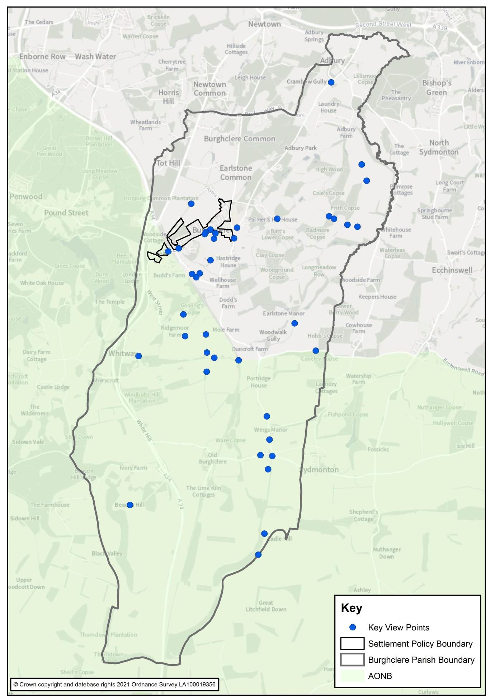
Plan F: Location of Important Views in Burghclere parish
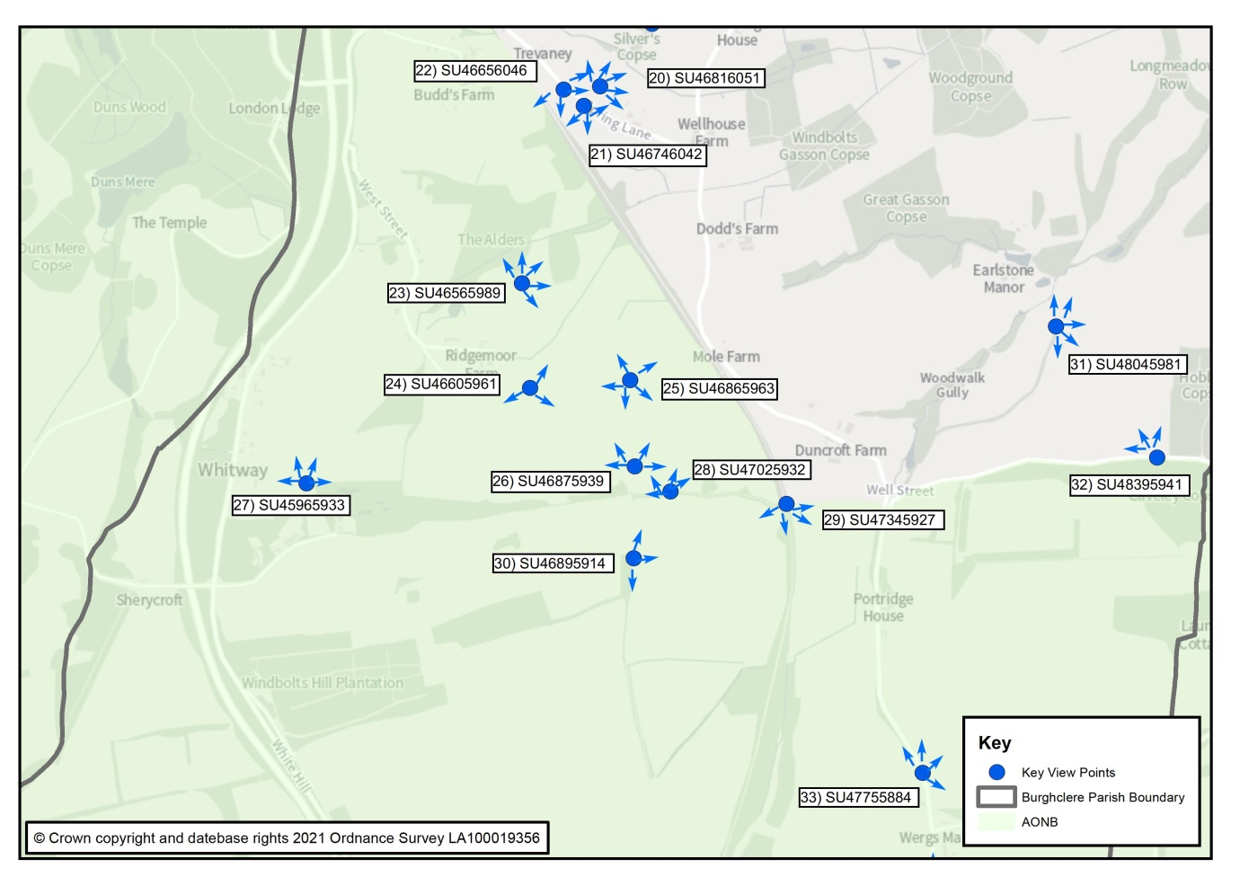
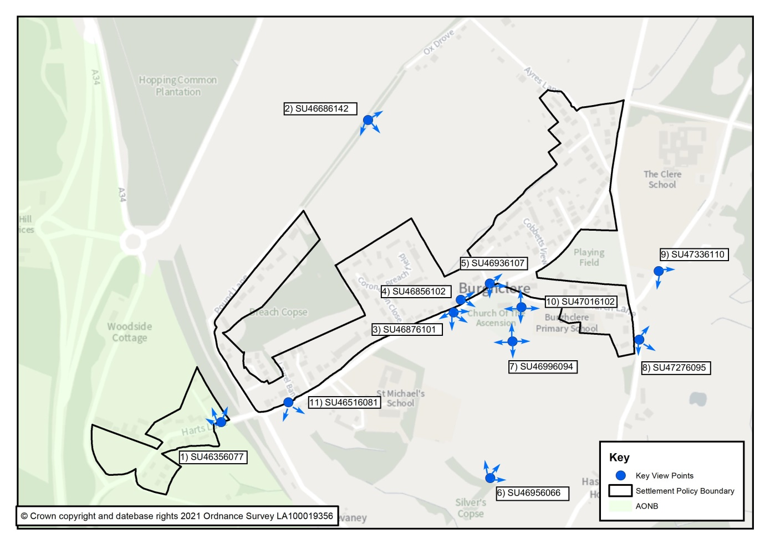
Plan G: Important Views to the South of the village
Plan H: Important Views in the village
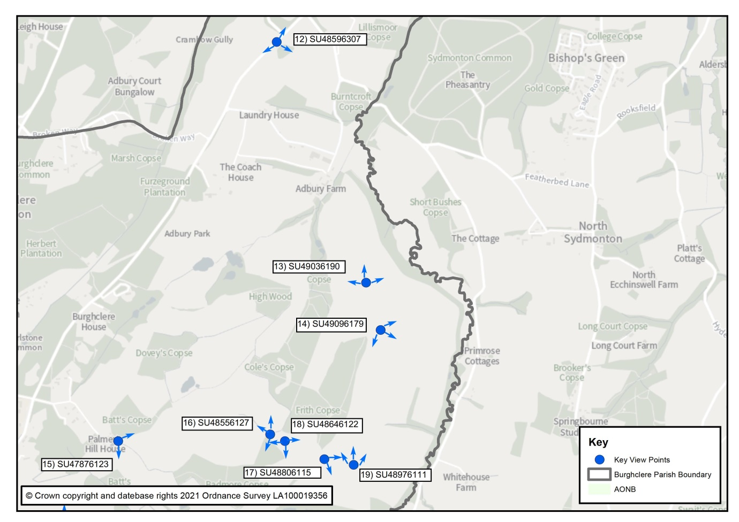
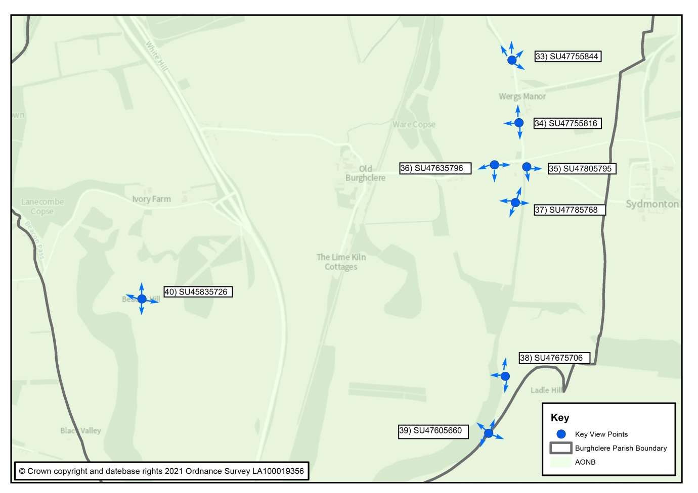
Plan I: Important Views in the southern part of the Parish

Plan J: Important Views in the northern part of the Parish
Policy B10: Green Infrastructure and Biodiversity
The Neighbourhood Plan identifies a Green Infrastructure Network, as shown on the Green Infrastructure Maps, for the purposes of promoting access to the countryside and ecological connectivity throughout the parish. The Network comprises Local Green Spaces, informal open spaces, footpaths, woodland, land of biodiversity value including designated environmental and landscape assets, Biodiversity Opportunity Areas, Nature Improvement Areas, or Species and Habitats of Principal Importance.
Development proposals that lie in the broad location of the network are required to have full regard to maintaining and improving the network, including delivering a ‘net gain’ to general biodiversity assets in the design of their layouts, landscaping schemes and public open space provisions.

Development proposals that will lead to the extension of the Network will be supported, provided they are consistent with all other relevant policies of the development plan.

  - The policy supports Local Plan Policy EM5 on Green Infrastructure by defining a network of green infrastructure assets in Burghclere parish as a means of increasing connection to the countryside and of improving local biodiversity through connecting habitats. It promotes the adopted Green Infrastructure Strategy for the Borough and provides local emphasis to Policy EM4 – Biodiversity, Geodiversity and Nature Conservation, in respect of requiring all relevant development proposals in the Parish to provide net gains in biodiversity.

  - The Natural Environment and Rural Communities Act 2006 places a biodiversity duty on all public authorities, (including local authorities) to have regard to the purpose of conserving biodiversity. Section 40 states that “Every public authority must, in exercising its functions, have regard, so far as is consistent with the proper exercise of those functions, to the purpose of conserving biodiversity.” This duty aims to raise the profile of biodiversity across the public sector and ensure that biodiversity conservation is at the heart of policymaking and service delivery for local planning authorities.
  - There are a number of opportunities for habitat creation and restoration that have been identified by Hampshire Biodiversity Information Centre (HBIC) as part of the East Woodhay to Headley Biodiversity Opportunity Area (BOA) – see Plan K insofar as it affects Burghclere Parish. This is not a statutory designation and does not infer a constraint to development or land use. A considerable number of Biodiversity Priority Habitats have been recognised within the Parish at Map L, several of those in the immediate vicinity of Burghclere Village (see Plan M).
  - Other notable areas that offer opportunities to promote biodiversity such as the trees and verges framing the approach to Burghclere from Newtown on Well Street, Well Street along the Recreation Ground, the approach from Adbury to Burghclere, and the Ox Drove have also been identified by HBIC as BOAs.

  - The policy therefore requires that all development proposals that lie within the broad location of the Network should consider how they may improve connectivity, or at the very least do not undermine its integrity of connecting spaces and habitats. This may mean that scheme layouts, access points, landscape schemes and amenity spaces are designed to contribute to the effectiveness of the Network where possible and without undermining other planning policy objectives. In some cases, proposals will enable the creation of new green infrastructure assets that extend the benefits of the Network. They will be supported provided they are appropriate in other respects.

Plan K: Biodiversity Action Plan Habitats & Designated Sites -within the Burghclere Parish boundaries
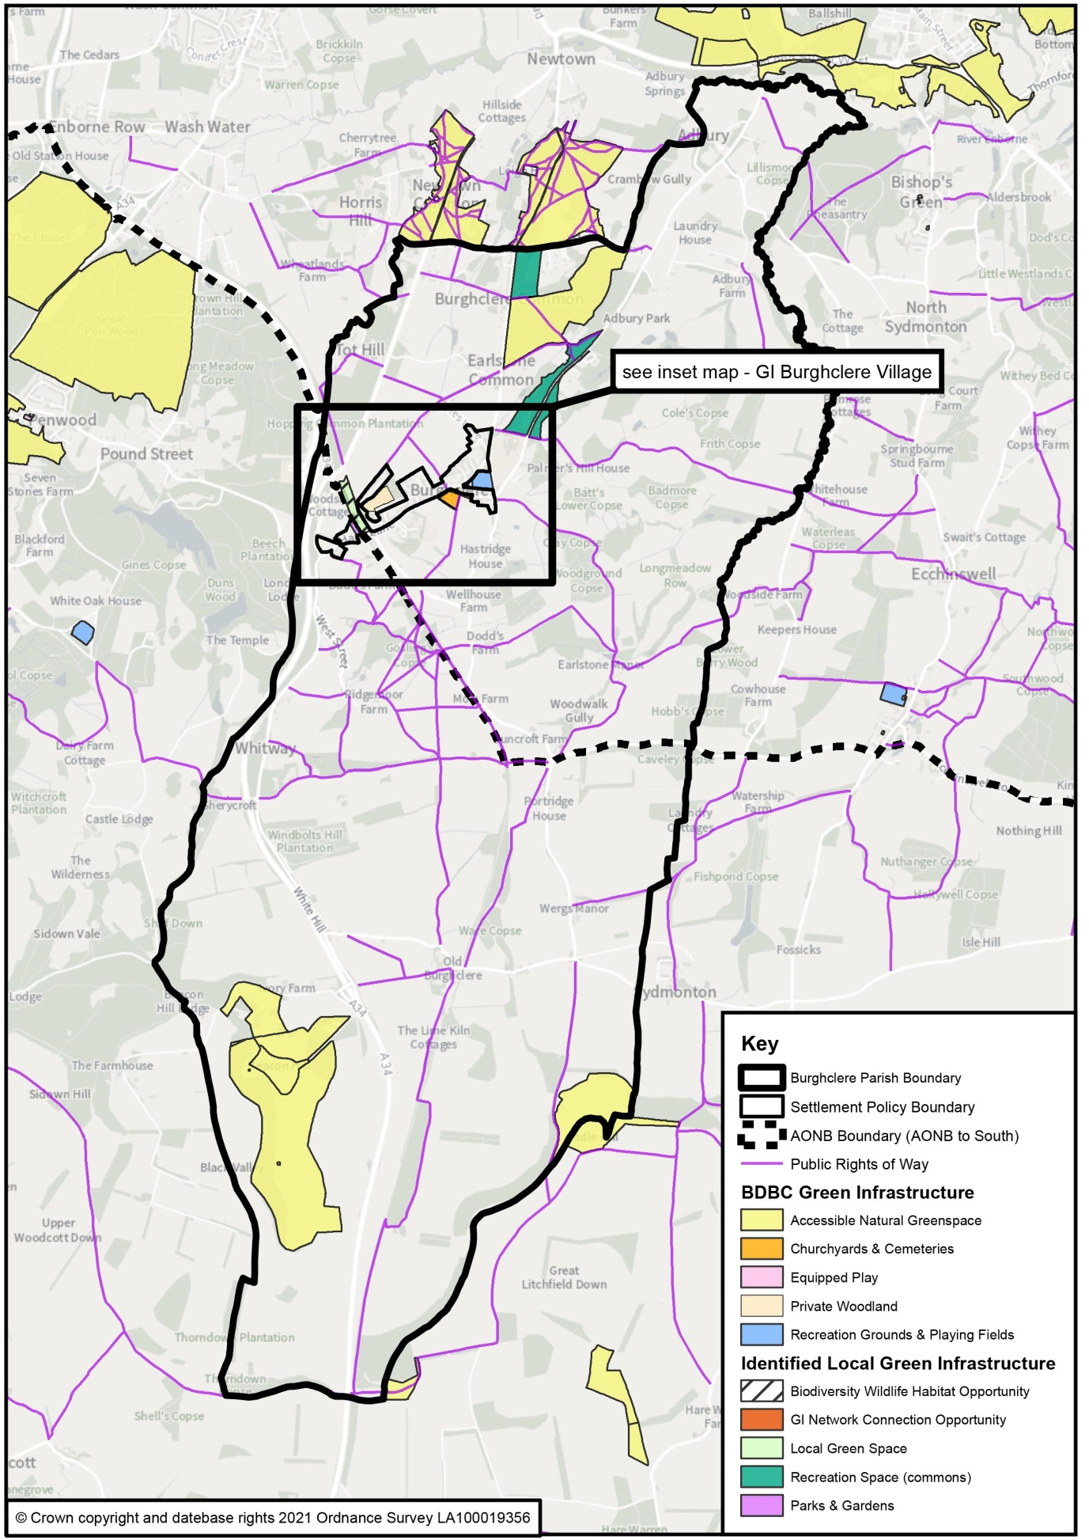
Plan L: Burghclere Green Infrastructure Network

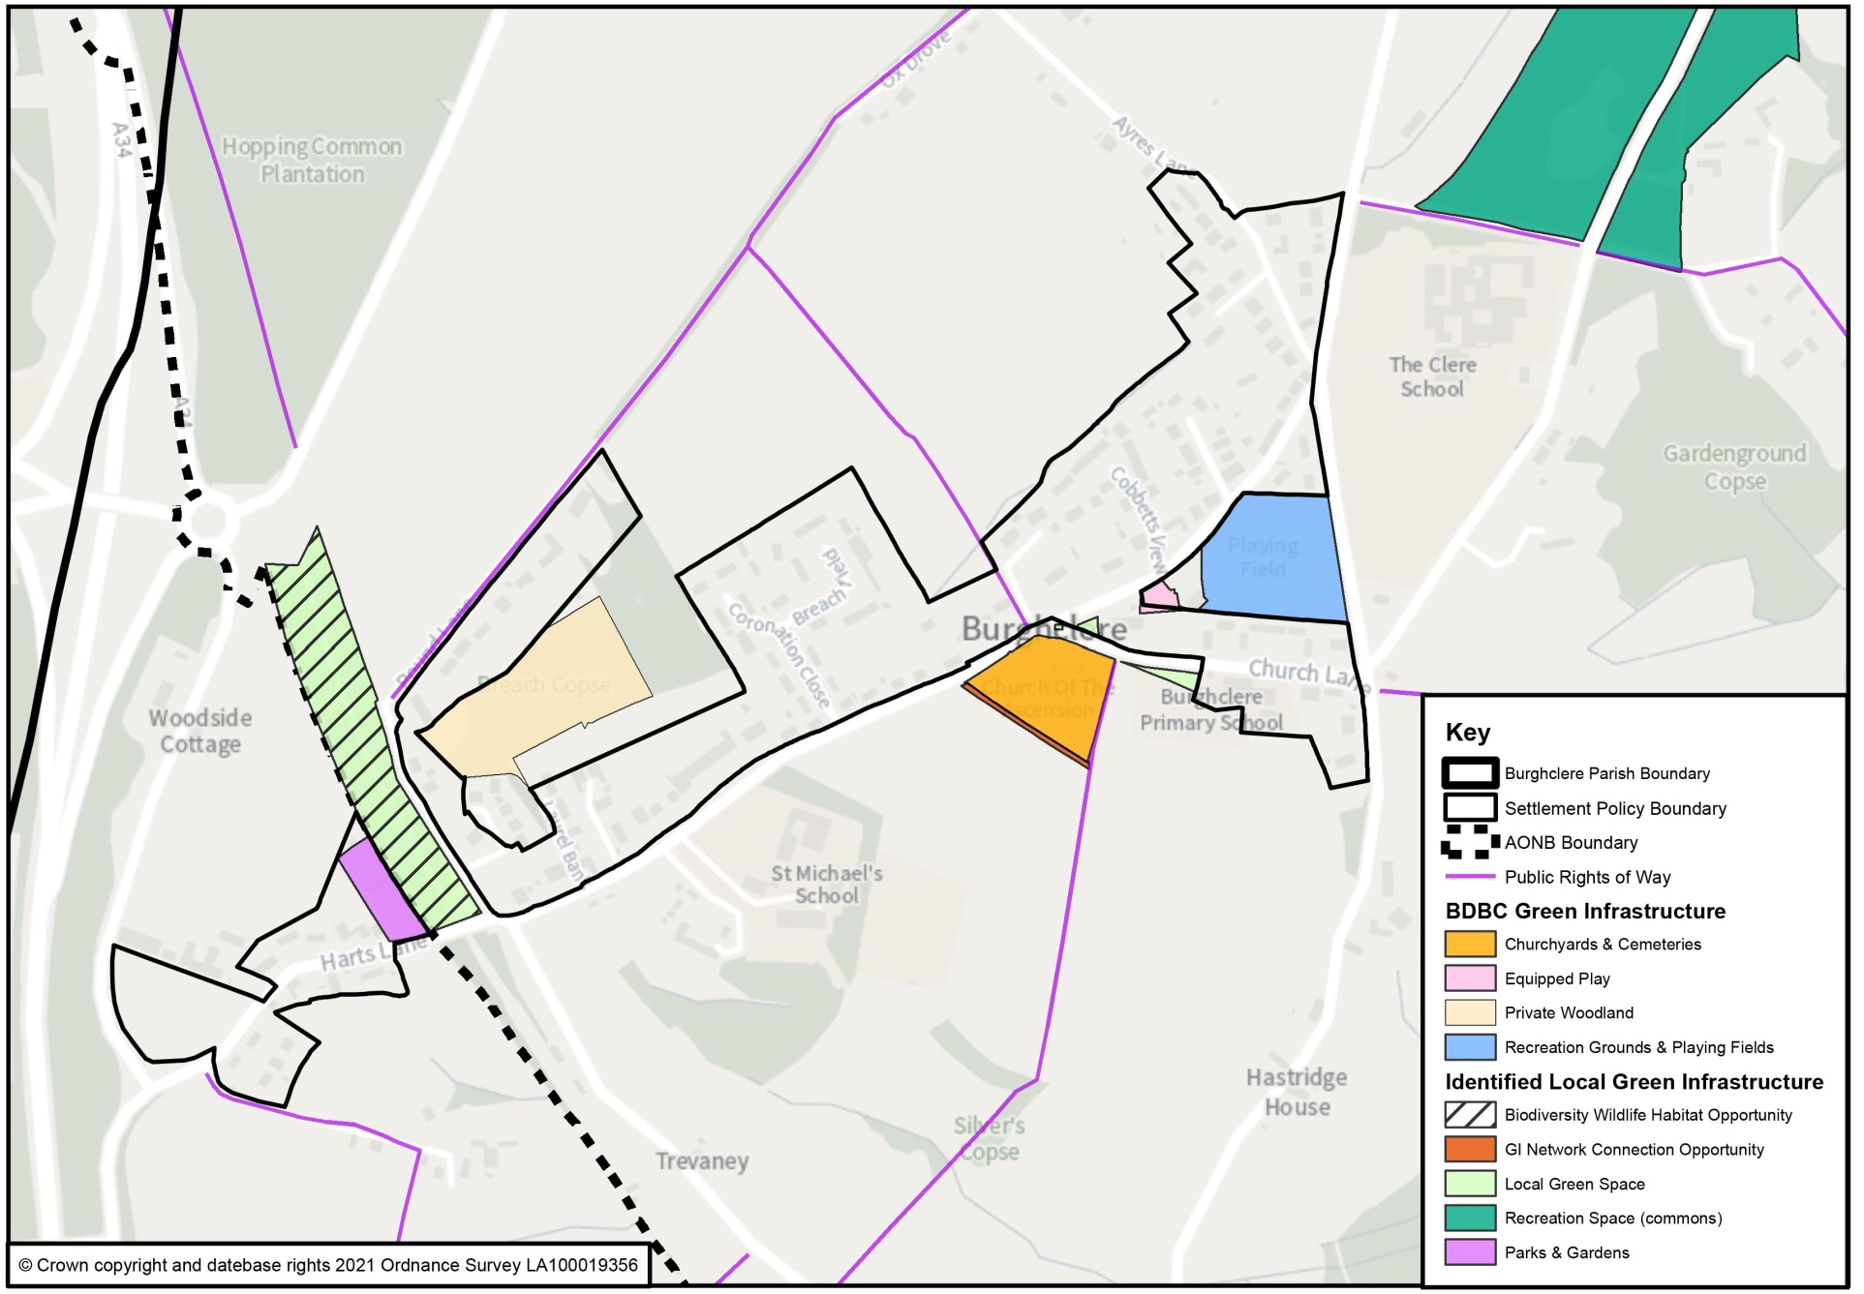

Plan M: Burghclere Village Green Infrastructure Network

Policy B11: Local Green Spaces

The Neighbourhood Plan designates the following locations, as shown on the Policies Maps, as Local Green Spaces:

LGS1 Memorial Garden, Portal Hall Grounds;
LGS2 War Memorial Green
LGS3 Green between Church of the Ascension and the School House
LGS4 Old Railway Line (North of Harts Lane)

New development will not be permitted on land designated as Local Green Space, unless very special circumstances can be demonstrated.

  - This policy proposes a number of important green spaces in the Parish - see Plan N - to be identified and protected by their designation as Local Green Space in accordance with paragraph 99 and 100 of the NPPF, drawn on consultation responses from the local community. Plans O and P show these in greater detail. The policy has the effect of managing development proposals in line with the NPPF provisions in the Green Belt, which prevent any development of the land unless the ‘very special circumstances’ test can be met. Furthermore, it complements B&DBC’s Green Infrastructure Strategy (November 2018) in consideration of health and well-being, recreation and leisure, and biodiversity factors.

  - This policy has been informed by the Burghclere Assessment of Local Green Space Report, included in the Evidence Base. The Report examines green infrastructure assets in the Parish, including those that already benefit from other designations, and describes how each identified Local Green Space meets the tests set out in national policy.

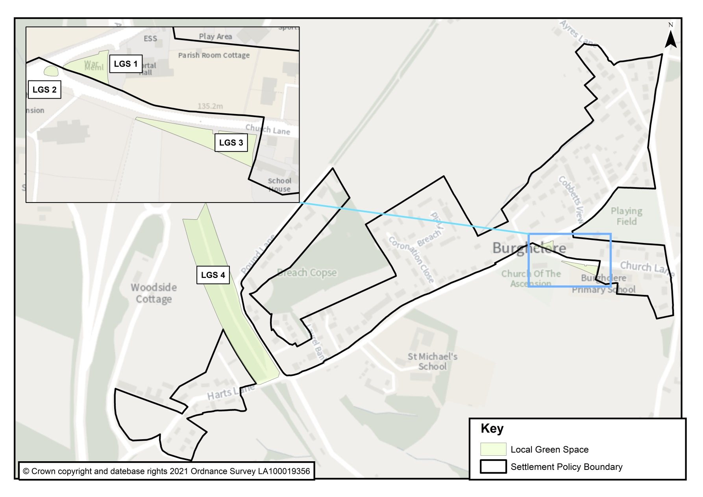

Plan N: Proposed Local Green Space

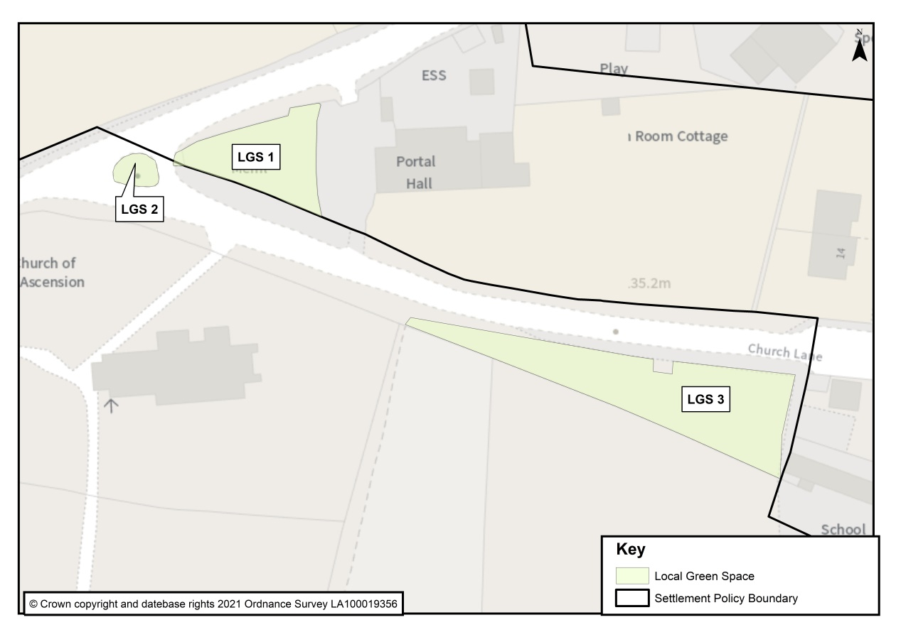
Plan O: Proposed Local Green Space – LGS 1, 2 & 3

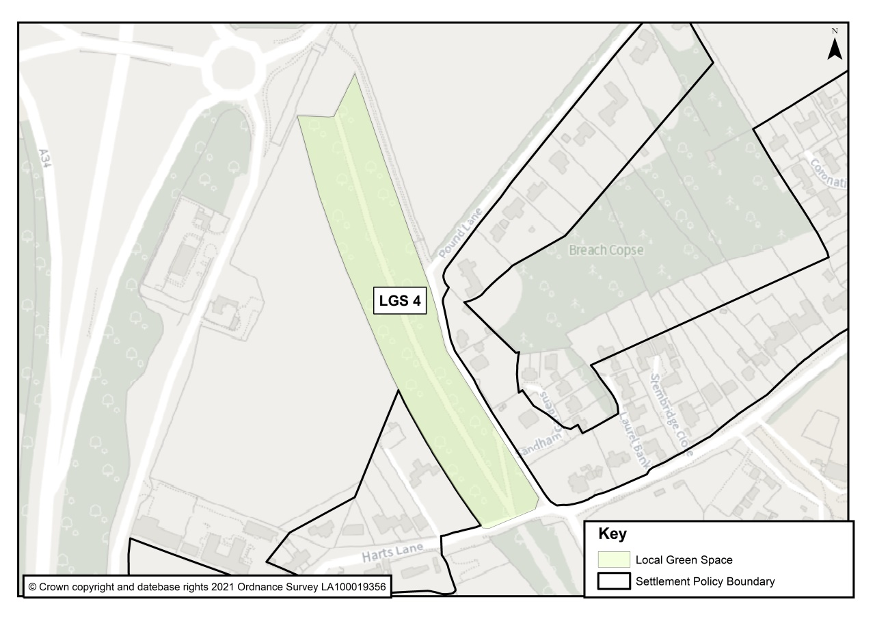

Plan P: Proposed Local Green Space LGS 4

Policy B12: Community Facilities
Proposals that will result in the unnecessary loss of a community facility, such as those listed below, will be resisted unless it can be clearly demonstrated that the use of the building and ancillary land is no longer viable or that the use can be satisfactorily re-located for the ongoing benefit of the local community:
- The Portal Hall, Church Lane, Burghclere, RG20 9HX
- The Millennium Garden, Church Lane, Burghclere, RG20 9HX
- The Allotments, Church Lane, Burghclere, RG20 9HX
- The Village Playground, Harts Lane, Burghclere, RG20 9JD
- The Village Car Park, Harts Lane, Burghclere, RG20 9JD
- The Recreational Field, Harts Lane, Burghclere, RG20 9JD
- Burghclere Sports Club, Harts Lane, Burghclere, RG20 9JD
- Church of Ascension, Burghclere, RG20 9HX
- Sandham Memorial Chapel, Harts Lane, Burghclere, RG20 9JT
- Carpenters Arms, Harts Lane, Burghclere, RG20 9JY
- Carnarvon Arms, Winchester Road, Whitway, Burghclere, RG20 9LE
- Burghclere Primary School, Church Lane, Burghclere, RG20 9HT
- The Clere School, Earlstone Common, Burghclere, RG20 9HP
Proposals to improve the viability of an established community use of the buildings and ancillary land by way of its extension or partial redevelopment will be supported, provided the design of the scheme and the resulting increase in use are appropriate in design terms and will not harm the amenities of adjoining residential properties.

  - The policy identifies those community facilities (buildings and land) that will be protected from a change of use and that encourages proposals to enable the facilities to remain viable community assets, in line with Basingstoke and Deane Borough Council Local Plan policy CN8 Community, Leisure and Cultural Facilities. It is recognised that the Burghclere Primary School Playing fields is already bound by Section 77 of the Schools Standards and Framework Act 1998 which sets out strict criteria to control the release of school playing fields for development, including requirements that the proceeds are used to enhance sports and/or education provision.

Policy B13: Tourism
Proposals to expand an existing tourist attraction will be supported, provided that the scheme has sufficient off-street car parking space; has regard to the amenities of adjoining residential properties; and is of a scale appropriate to its location.
  - The existing tourist attractions in the parish include the National Trust property, Sandham Memorial Chapel, which draw a number of visitors per year. There are many popular walking footpaths, such as the Brenda Parker Trail, as well as the Commons, which draw walking groups, schools and local families. Within the North Wessex Downs Area of Outstanding Natural Beauty Beacon Hill is oft frequented, although mostly from passing tourist traffic. The biggest local draw is Highclere Castle and its many events, attended by people from across the country and around the world. Although only a small part is located in the parish it too contributes to the tourist economy in Burghclere.
  - For the most part the key attractions have their own plans and programmes; the principal benefit to the parish is through provision of accommodation and meals and are in part season or weather dependent. Nevertheless, the local initiative to build a steam model railway track around the recreation ground has seen other enthusiasts, families and friends flock to events that benefit the Sports Club and other local outlets.
  - Tourists and visitors are welcome and benefit local economic activity. Those facilities require support, maintenance and enhancement, whilst respecting the character of the local area and AONB. Engagement and dialogue with the relevant managing authorities can benefit the use of these sites and contribute to increased employment and prosperity. The policy is intended to support the growth of the tourist economy by protecting existing tourist attractions and encouraging investment in the tourism offer of the area.

Policy B14 – Car Parking

In addition to the provisions of relevant Local Plan policies, all new parking should be provided off-street, unless an essential justification can be demonstrated. Proposals to establish a new public car park at a suitable location in the village will be supported.

  - The policy seeks to address car parking challenges affecting many residents of the village by encouraging proposals to establish a new public car park and by ensuring development proposals can demonstrate they will include adequate off-street car parking spaces within their schemes. This can include using residential frontages to create new car parking spaces providing there is no negative impact on the existing boundary treatment.

  - Basingstoke and Deane’s Parking Supplementary Planning Document (2018) provides further detail to the adopted policies of the Local Plan, specifically Policies CN9 and EM10, and replaces the previous 2008 (updated 2012) version and the Hampshire Parking Strategy and Standards (2002). The levels of provision required varies across the borough to reflect the more rural nature of some settlements and assists in maintaining vitality and viability in smaller settlements where alternative modes of transport may not be so readily available. Although, the village of Burghclere is well connected to its surrounding towns, villages and stations, journeys through necessity are essentially by car. The parking standards for Burghclere are therefore those set out for a rural settlement.

  - Car parking is in short supply in the village. An analysis for on-street and off-street car parking space demonstrates where demand outstrips supply (see Plan Q overleaf). While on-street parking can restrict vehicle speeds through the village, it also increases the risk of an accident when overtaking parked vehicles. The design of new development must therefore recognise the dependence of village life on private transport and provide adequate off-road parking. Although parking on-street on Harts Lane is commonplace, Church Lane in particular suffers from bottlenecks in school term time, during the many events held at the Church of Ascension, Portal Hall, Burghclere Primary School, the Sports Club and on the Recreation Ground where on-street or existing car parking arrangements cannot meet the demand. Temporary (and only on request) parking in the field next to the Church mitigates the problem but is not of itself a solution. The policy therefore allows for new spaces to be created as required by the development plan and, potentially, a new public car park in the centre of the village.

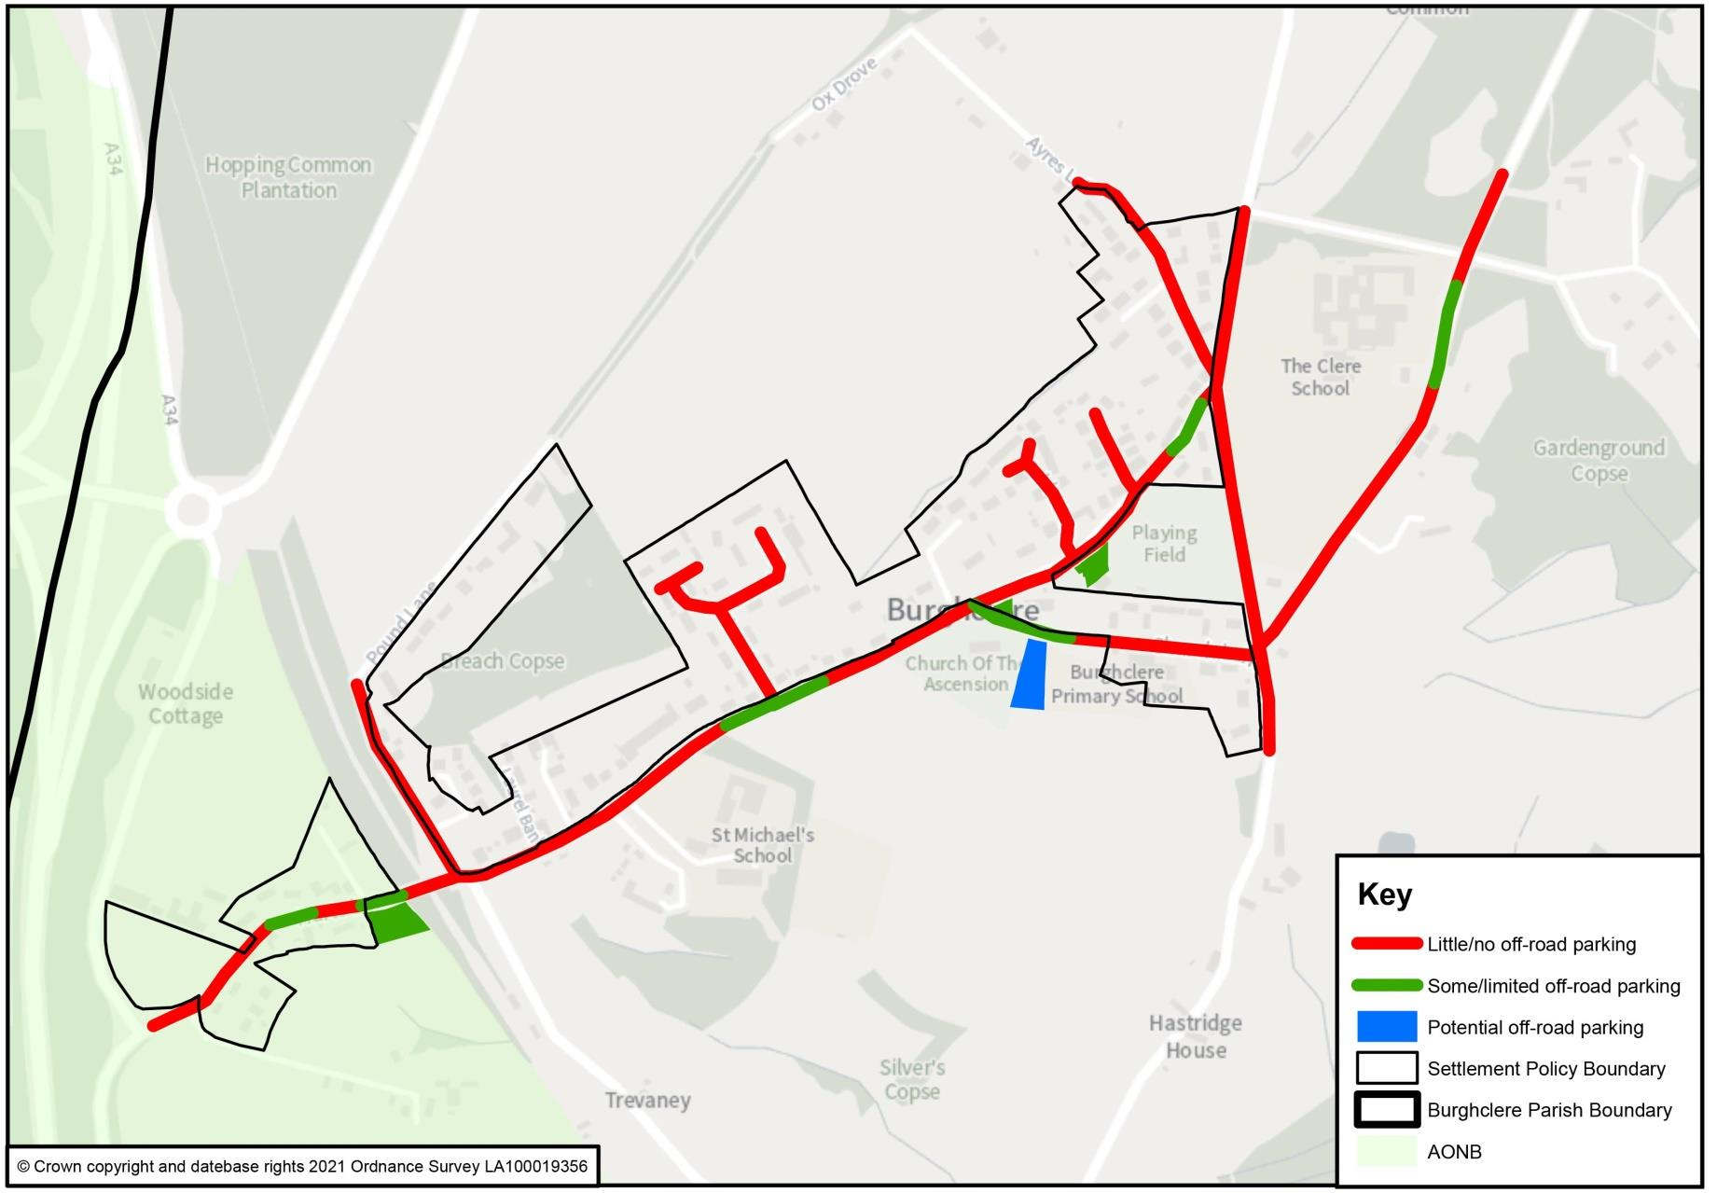

Plan Q: Burghclere Village Car Parking analysis

6. IMPLEMENTATION
6.1 The Neighbourhood Plan will be implemented through Basingstoke & Deane Council consideration and determination of planning applications for development in the Parish.
Development Management
6.2 The Parish Council will use a combination of the Local Plan and this Neighbourhood Plan’s policies to inform and determine its planning application decisions. The Parish Council is a statutory consultee on planning applications made in the Parish and it will be made aware of any future planning applications or alterations to those applications by the planning authority. It will seek to ensure that the Neighbourhood Plan policies have been identified and applied correctly by applicants and by officers in their decision reports.
6.3 Where necessary, the Parish Council may seek to persuade the Secretary of State to call-in a planning application that it considers is in conflict with the Neighbourhood Plan but which the planning authority has deemed to consent. Similarly, it may also seek to persuade the Secretary of State to recover an appeal of a refused application, where the conflict with one or more Neighbourhood Plan policies has been important in the reasons for refusal. In both cases, the Parish Council will do so if it considers matters of national policy significance (for neighbourhood planning) are raised.
Local Infrastructure Improvements
6.4 Where opportunities arise through Section 106 agreements (or through the Community Infrastructure Levy) to secure financial contributions to invest in improving local infrastructure, the Parish Council will review the evidence base and community consultations for the Neighbourhood Plan to inform its view in liaising with the local planning authorities. A preliminary list has been set out below. This is in addition to the infrastructure projects that are proposed to be delivered through site specific policies in this Neighbourhood Plan. Some of these have been collated as:
- Contributing towards enhancing in-village car park facilities e.g. a new car park.
- Repair and renovation of the Sports Club (replacement might also be considered).
- Portal Hall renovations:
- replace current windows for the original design.
- upgrade kitchen.
- renovate flooring.
- renew lighting.
- Existing Recreation Ground Play Area – add additional play equipment and equipment for all age groups, including the elderly.
- Resolving sewerage and storm water flooding problems in the village.

Other Non-Planning Matters
6.5 During the process of preparing the Neighbourhood Plan, there have been many ideas for improving or addressing current problems in the Parish that lie outside the scope of the land use planning system to control. The Parish Council has noted these issues and will take them forward through its day-to-day business and in partnership with the local community and relevant parties.

Appendix:

      - Design Statement.

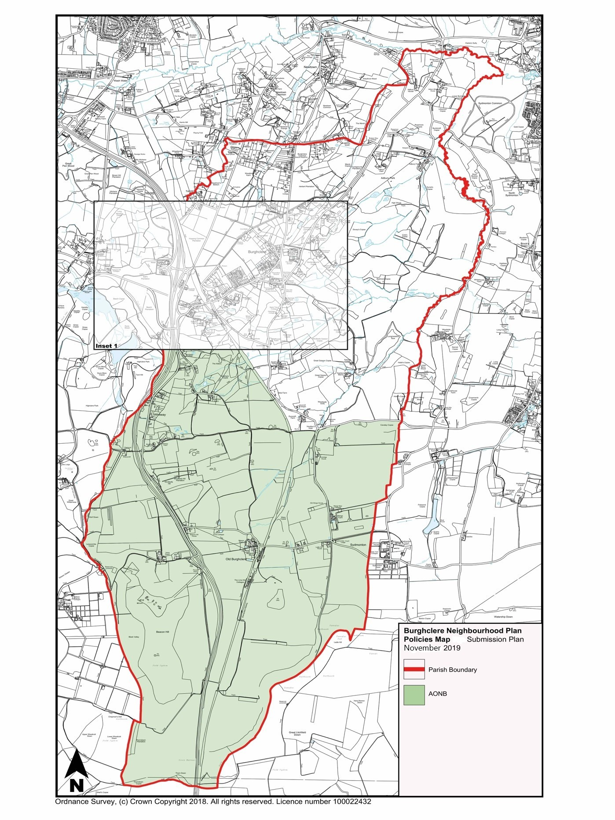
POLICY & INSET MAPS

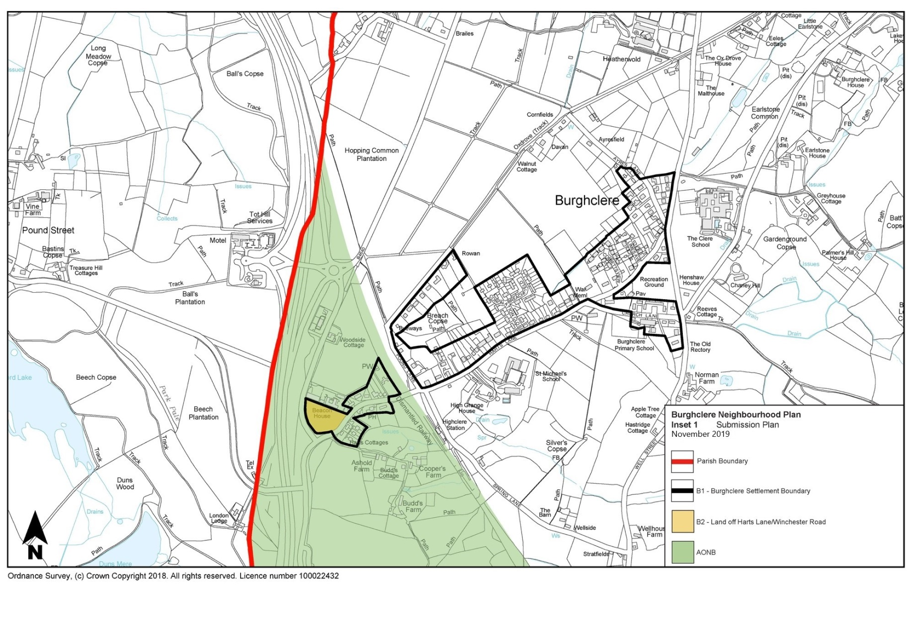
INSET MAP
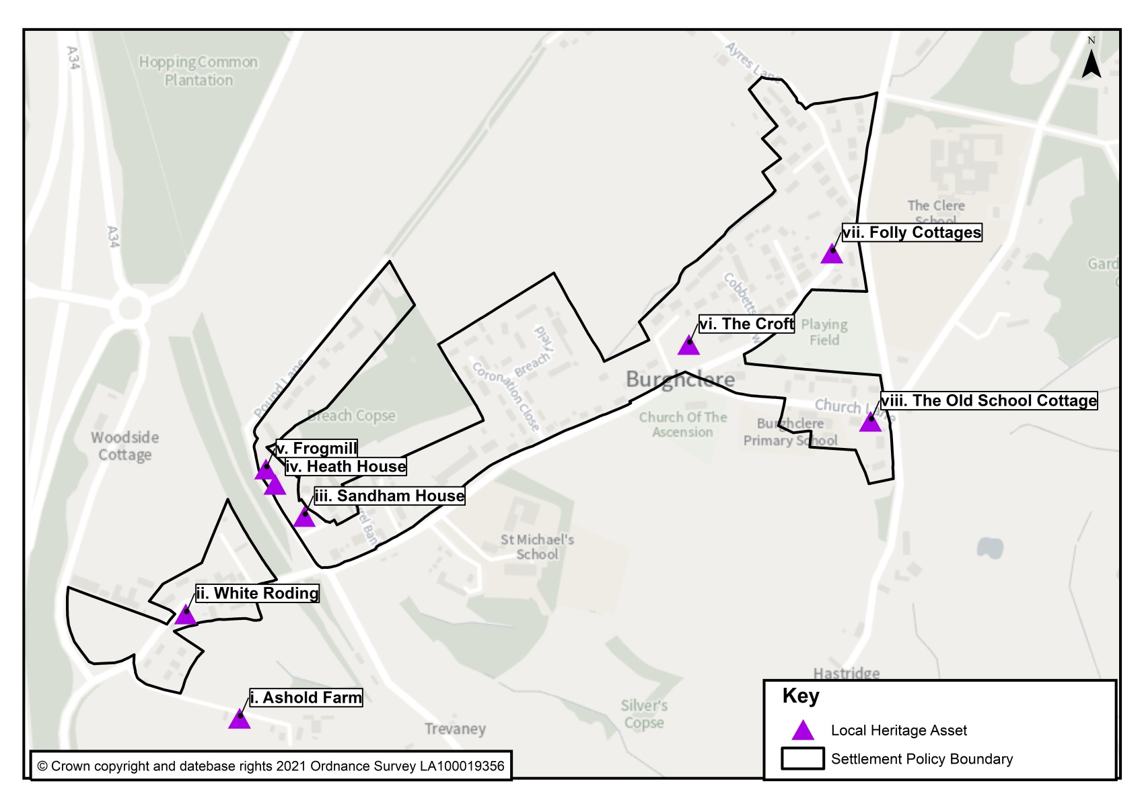
INSET MAP 2

Burghclere Village Local Heritage Assets

SCHEDULE OF EVIDENCE

The list below contains all documents prepared, collected and reviewed in the process of preparing the Plan.

BDBC Neighbourhood Plan SEA/HRA Screening Report – Burghclere Nov 2018
Burghclere NP SEA Scoping Report V2.0 (AECOM March 2019)
Burghclere NP Final Sustainability Appraisal Report (AECOM Nov 2019)
Burghclere NP Basic Conditions Statement
Burghclere NP Consultation Statement
Burghclere NP supporting documents:
Site Selection Report (20191106)
Major Development within the NWD AONB (20190716)
Traffic and Parking (20190914)
Tourism (20190914)
Green Infrastructure (20190916)
Local Greenspaces (20190916)
Key Views (20190916)
Design Statement (20190914)
Business (20181119)
Rural Business Hub (20181117)
Business Needs Survey Report (20191106)
Community Facilities Buildings and Land Report (20180627)
Residential Garden Land Policy Justification (20191010)
Land off Harts Lane/Winchester Road Supporting Documents
Access Technical Note
Arboricultural Impact Assessment
Flood Risk and Drainage Note
Historical Environment Note
Initial Landscape and Visual Appraisal
Preliminary Ecological Appraisal
BDBC Local Plan, Supplementary Planning Documents and Evidence base
Basingstoke and Deane Landscape Character Appraisal (2002)
North Wessex Down AONB Management Plan 2019 – 2024 (Draft)
National Design Guide (October 2019)

Appendix 1
to Referendum version
Burghclere NP
Burghclere NP-Design Statement

The purpose of this design statement is to provide planners, architects, design technicians and applicants with a framework to assess design priorities of future physical development in the parish. It informs users which aspects and features of special architectural and historic interest are considered by the community to make a positive, important and special contribution. This statement is also aimed at encouraging all residents to continue an active interest in the future shaping of the natural and built environment of the parish as a whole.

This statement is material consideration for development applications in the parish and forms an integral part of the Neighbourhood Plan. Its use will contribute to the delivery of development proposals that protect and enhance the character of Burghclere village and outlying areas. It first sets out principles, context and policy guidance, describes the local landscape before considering Burghclere village itself in order to focus on detailed issues such as layout, building design and issues concerning materials and detailing. Moreover, the description and details noted allow for easy reference when conducting a contextual survey and analysis both within the village townscape and without.

Principles, Context and Character

Parish development aims to create places for people first and foremost. Co-operation, collaboration and transparency are essential hallmarks of the development process to ensure well designed, high quality environments. Designs must retain the qualities of the traditions of the area, maintaining a strong sense of place, continuity of form and richness of variety and detail. Innovation, modern design and technological change all have a place in shaping the environment of the future and can be an original response if done sympathetically and in context. Overuse of standard designs, not informed by the specific site context will not be acceptable, nor will pastiche or replicating mediocre design. Inclusion of high quality, well designed external environments is the essence of this policy as they will support Green Infrastructure initiatives and importantly contribute to the well-being and health of the local community.

Planning Policy

This Statement draws from and is linked to the Government’s National Planning Policy Framework (NPPF), B&DBC’s Local Plan and its Supplementary Planning Documents dealing inter alia with Housing, Design and Sustainability, Parking, Conservation and Historic Environment, and Landscape and Biodiversity. Policies contained within this document reflect the intent of the aforementioned and are further tailored to the specific circumstances of the parish.

Landscape Overview

Burghclere parish has a varied geology of clays, silts and sands, giving rise to a diverse mix of soils and a mosaic of ancient semi-natural woodlands, plantations, remnant heathland and open farmland areas. Sitting to the South of Newbury and the lower Kennet valley this is referred to as Lowland Mosaic by the North Wessex Downs Area of Outstanding Natural Beauty (NWD AONB) and permits a wide diversity of flora and fauna.

The northern boundary of the Parish runs along the River Enborne from which the ground gently rises to more densely wooded flat terrain interspersed by low density hamlets such as Adbury, Adbury Holt and Tothill, with Newtown common adjoining Burghclere Common, the Herbert Plantation and Earlstone Common - all of which are Countryside Heritage Sites - before arriving at Burghclere village itself. There are several small streams and springs in the lower part of the parish that feed into the River Enborne. Most of the village is on level terrain and to the North and West looks across open fields towards the A34 and the commons. To the South and East, the ground is more open, principally farmland with occasional woods and copses and offers outstanding views towards Sydmonton, the Watership Down ridgeline and Old Burghclere, which is itself overlooked by Ladle and Beacon Hills that straddle the A34 as it passes South towards Winchester. The parish is fortunate in not only having a large number of designated conservation sites; the NWD AONB, Ancient Woodlands, Sites of Special Scientific Interest (SSSI) and Sites of Interest for Nature Conservation (SINC), but also many listed buildings.

Essential characteristics: Burghclere village

The village itself is largely linear and is orientated NE-SW. A map of Burghclere settlement boundary is at Annex A. Bisecting the southern half of the parish is the NWD AONB, which follows the line of the old Didcot-Newbury-Southampton railway through the south-western segment of the village. Growing haphazardly over the last 200 years, the middle of the village centres around the Church of the Ascension, War Memorial, Portal Hall and Village Green. The Church and Portal Hall date from the mid-late 19th century and make a cohesive and visually coherent association.

The bulk of Burghclere village lies inside the designated Settlement Policy Boundary (SPB) and comprises of a mix of building types in terms of age, size, form, style, construction and history. Houses are generally spread along the Harts Lane and Church Lane, with development running North up Well St. Some domestic and rural buildings date from the 17th century or earlier. Several developments branch off from Harts Lane, the main thoroughfare. Although many houses are set back from the roads behind hedges that soften the streetscape, modern houses can be found adjacent or opposite older ones as a consequence of its historical growth and a less than coherent approach to planning over the years.

At the southerly end a small number of houses lie on Coopers Lane that leads to Grade II listed Budds Farm, which dates to the 18th century. Entering the village on Harts Lane one of the finest examples of an early primitive Methodist Chapel, built by the Reverend Thomas Russell in 1864, has been converted into a residence known as Parsons Corner. The last remaining pub in the village is the Carpenter’s Arms, dating from the mid 19th century, which has undergone extensive modernisation but has retained its historic façade and interior. Nearby is the National Trust property Sandham Memorial Chapel, built in the 20th century, which contains the internationally important paintings by Sir Stanley Spencer undertaken between 1926 and 1932. Parking for visitors has recently been provided in a field opposite.

To the East of the railway bridge a narrow road, Pound Lane, runs NE to another small set of properties, which then turns into unpaved track. In 2017, five modern houses were built in the grounds of Sandham House, which blend in well; several of the houses beyond are bungalows and have minimal impact on the landscape on that side of the village.

Almost opposite Pound Lane, Spring Lane runs SE off which lie a smaller number of houses, some of which date back to the 18/19 th centuries. Continuing NE along Harts Lane, there are two new developments off the main road; Laurel Bank and Stembridge Close. Beyond are a collection of large houses of varying styles and ages, with extensive gardens that provide an attractive streetscape until Breachfield and Coronation Close are reached. This is a relatively modern development, built in stages during the 1950s. As a block these houses are less sympathetic to the earlier style of development within the village, fronting respective roads, with less hedging acting as a screen.

Further to the East is the village centre and beyond that a number of 20 th century houses that all sit comfortably in the streetscape of this area. A development of 18 houses in Cobbetts View was built in the last decade. Although modern in design they have been sympathetically constructed, barely visible to those passing on Harts Lane, and have been well landscaped. Limes Avenue holds another small housing settlement, after which there are a series of small houses that front Harts Lane, including the old Post Office and the Queen’s pub that have been converted for private use. After the junction of Harts Lane and Well Street, Ayres Lane runs NW, along which are a number of properties before the intersection with the Ox Drove.

Running East from the village centre is Church Lane, on which sits Burghclere Primary School, an old building dating back to the 19 th century, with a series of houses beyond of mixed style but which conform to the village character. Opposite these is Elkington Close, a series of brick bungalows built in the 1970s, many of which are in housing association use.

Within the village are four schools; St Michael’s on Harts Lane, owned and operated by the Society of St Pius X, Burghclere pre-school, which uses the facilities in and outside the Portal Hall, Burghclere Primary School on Church Lane, and the Clere School, a co-educational community secondary school on the C183 Aldern Bridge Road. The latter is the most recent construction dating from the 1960s and boasts a fine new sports extension, although its notable slanted roof is somewhat incongruous in a rural village setting.

Architectural Character and Quality of Buildings

Hampshire County Council’s Historic Environment Record (HER) lists in its Archeology and Historic Buildings Record over 257 entries for Burghclere, attesting to the historical richness of the parish.

There are 57 listed buildings in the parish including 3 Grade 1 and one Grade II*. Five listed buildings are within Burghclere’s SPB.

There are buildings within the village that are not recorded or listed but which have unusual design features or local historical resonance. When the Village Design Statement (VDS) was compiled in 2001, an informal survey was carried out and a number of buildings were listed separately that recognised their uniqueness but conferred no special privileges or protection. This list was submitted to B&DBC with the VDS who, in 2007 compiled a ‘Local List of Buildings of Architectural or Historic Interest - Burghclere’ (BAHI). Another survey was carried out in 2018 and a further set were noted and it is intended to add those to the BAHI as well; these are indicated below.

Burghclere village

In the village centre the Grade II Church of the Ascension dominates. A slate-roofed Anglican church, it was constructed in 1838 and enlarged in 1875. Originally with a plain wide nave with shallow transepts and chancel and with a western tower, it was extended eastwards by the attachment of a long chancel, with a south aisle and north vestry. The interior has a chancel screen of open traceried timber work above a stone dado wall, steps, stalls, communion rail, sedilia, and brass eagle lectern.

Adjacent to the church is Burghclere War Memorial, designated at Grade II as a permanent testament to the sacrifice made by the community in two World Wars and as a simple tribute to the Fallen of Burghclere. Standing in a grass triangle at the junction of Harts and Church Lanes, the memorial has a visual relationship with the Portal Hall and the Church of the Ascension.

Opposite the church is the Grade II listed Portal Hall (sometimes referred to as Parish Room and House) built in 1890. It is a commemorative building in the Arts and Crafts style, comprising a main block of 6 bays, with a dwelling attached at the east end. It has a steeply-pitched tile roof and ribbed chimney stacks.

Returning to the SW end of the village Holmbush Cottage is a very pretty building of early 19th century construction of red brick and occasional blue header and a slate roof, listed in the HER.

On Coopers Lane, Budds Farmhouse is Grade II listed and dates from the 18th early 19th century. On its West elevation of 2 storeys are 6 windows and hipped tile roof with molded brick cornice to the eaves. Painted brick walling is in Flemish bond, with some flint panels, first floor band, cambered openings, with molding to the plinth, and mid 19 th cast-iron casements with large diamond design. The house is associated with William Cobbett as being the starting point of his Rural Rides in 1821. The17 th century Coopers Farmhouse is Grade II listed and its stable and three barns are on the HER. Ashold Farm, although not on the HER is for BAHI consideration. Parsons Corner on Harts Lane has already been mentioned as a fine example of an early Methodist Chapel with red brick wall with buff brick window dressings and gauged arches. The Carpenters Arms is a mid-19 th century building, HER listed, with plain rendered walls, probably covering brick, with a single storey ancillary building to the East. Both Laburnum Cottage and the outbuilding to its West are HER listed; the gable contains a diamond with the date 1677. Opposite is White Roding, a private house of red brick with attractive roof ridges proposed as a BAHI. Sandham Memorial Chapel, owned by the National Trust, is a plain rectangular block of red brickwork and is Grade II listed. The South side is arranged in symmetry with a single storey almshouse on each side and in front, an attractive formal garden.

At the junction of Pound and Harts Lane sits Grange Cottage, a white painted brick house of early 18 th century, HER listed with a plain clay tile roof. A short way up Pound Lane is Sandham House, where Sir Stanley Spencer lived during the time he painted the murals. Although now part of Sandham Close and not easily visible from the road, the building merits being included as a BAHI, as do Heath House and Frogmill, the two attractive houses next to Sandham further up the lane.

To the South of Harts Lane is Spring Lane, leading to a number of houses before it joins Well Street. Of note is The Old Station, built in 1885 and sympathetically converted from its original use to a private home. Since it retains much of its original brickwork and looks it is already listed as a BAHI.

Opposite the War Memorial on Harts Lane, set back from the road, is The Croft, a large house dating from the late 19 th /early 20 th century that, together with Folly Cottages, a whitewashed set of workers’ cottages that date from the 1920s are worthy for BAHI incorporation. Sitting at the junction of Harts Lane, Ayres Lane and Well Street is Ladle House, HER listed, formerly the Queen’s pub, circa 1867, built with a symmetrical façade and its main door beneath a slated veranda roof.

At the junction of Well Street and Church Lane is Reeves Cottage dating from 1833, red brick with gabled and hipped clay plain tiled roofs, which has recently been sympathetically extended. Beyond that on Well Street is The Old Rectory, a two-storey former rectory dating ^{f}rom the 19 th and 20 th centuries. Both are HER listed.

On Church Lane is The Old School Cottage, a low white-painted building which merits BAHI inclusion given its unusual roofline. Burghclere Primary School (HER listed) dates to the early-mid 19 th century and comprises a tall white-painted brick single-storey main block with attached two-storey masters House at the western end.

Materials

Buildings from the Georgian period have sash or casement windows, hipped roofs, some with slate coverings and overhanging eaves. Late Victorian buildings are mainly in red wire-cut bricks with typically Victorian ornate gables and other embellishments such as denticulation. Many of the older cottages and some more recent buildings have roofs with hipped ends, being covered with plain clay or concrete tiles. Several have interesting and ornate chimneys and a number of traditional farm buildings have weather-boarded elevations. A few older buildings are thatched, adding to the diverse character of the parish.

Brick is the predominant material, of a variety of colours and sometimes colour-washed. Some buildings have tile-hung elevations. Slate covering are used on a number of late Victorian/early 20 th century buildings, particularly in Heatherwold. Many of the originally modest houses have been extended considerably to a high standard that blend in with the original and harmonise with neighbouring properties, but examples of poor quality extensions with architectural features out of keeping are also evident. On some of the larger plots infilling has occurred, and the scope for this is increasingly difficult to manage without detriment to the character and appeal of the settlement.

Trees and vegetation

Burghclere village is blessed with extensive arboreal cover that adds significantly to the rural aspect of the village; the roads running North from the village especially so. Breach Copse, although in private hands, has been a local feature since the 1800s. Many fine specimens are within gardens or properties and collectively contribute to the character of the area as a whole.

Green Space

The agricultural and equine fields within and around Burghclere village create a rural ambience, engagement with the countryside and provide attractive views and tranquil vistas. Across the parish open spaces offer long-distance views to or from the high Downs, while wooded areas and dales offer seclusion and intimacy thanks to the many mature trees and shrubs growing in gardens and the wild. Green Spaces have been identified and a separate report provided.

Footpaths and Byways

The parish is honeycombed with over forty footpaths and ridgeways. All are much used by the community and visiting walkers from further afield. Future development should include consideration of how to improve the existing layout or create new recreational opportunities.

Views

Important views have been identified within the village looking in as well as out. A Key View report has been compiled and includes other significant views recorded around the Parish.

Of particular note are those that demonstrate the close links of the village with the countryside on to the North from Pound Lane/Ox Drove, and to the South looking both out to the Downs from several points as well as looking into the village. Development in either of these areas would significantly impact on the rural character and feel of the village.

Design Guidance

General Principles

To safeguard, preserve and enhance the appearance and special character of Burghclere parish and the Settlement Policy Boundary area, the following guidance should be considered when preparing and assessing the appropriateness of planning applications and also any development that might affect the visual characteristics of the settlement areas within and without the AONB.

Development should in all regards be in compliance with policies in this Plan and respect the historic pattern of existing building lines and building orientation of the immediately adjacent plots where a consistent pattern is prevalent. Where a pattern is not clear proposals should reflect the wider mix of historic building lines and building orientation in the relevant area. The building heights of any such developments should not exceed the prevailing roof line of the adjacent plots.

Any new building works should be designed not as a separate entity but should be sympathetic in form and scale with the existing historic or traditional buildings within the local area.

Any new building works should use materials that complement those used in adjoining or adjacent buildings, particularly when such buildings are listed, include features of particular visual interest or are listed as BAHI.

Although hedges cannot be specifically protected, existing tracts of native or traditional hedging, including those hedgerows indicated on policy maps should be retained and where possible enhanced.

Areas of open space and gaps between buildings which contribute to the character of the area should be protected from development.

There should be no development that negatively impacts on the character of a key view into, out of or through the area as shown on the policy maps.

The rural character of the roads and streetscape in the area should be maintained.
Annex A
Appendix 1
Burghclere referendum NP
Burghclere Settlement Boundary
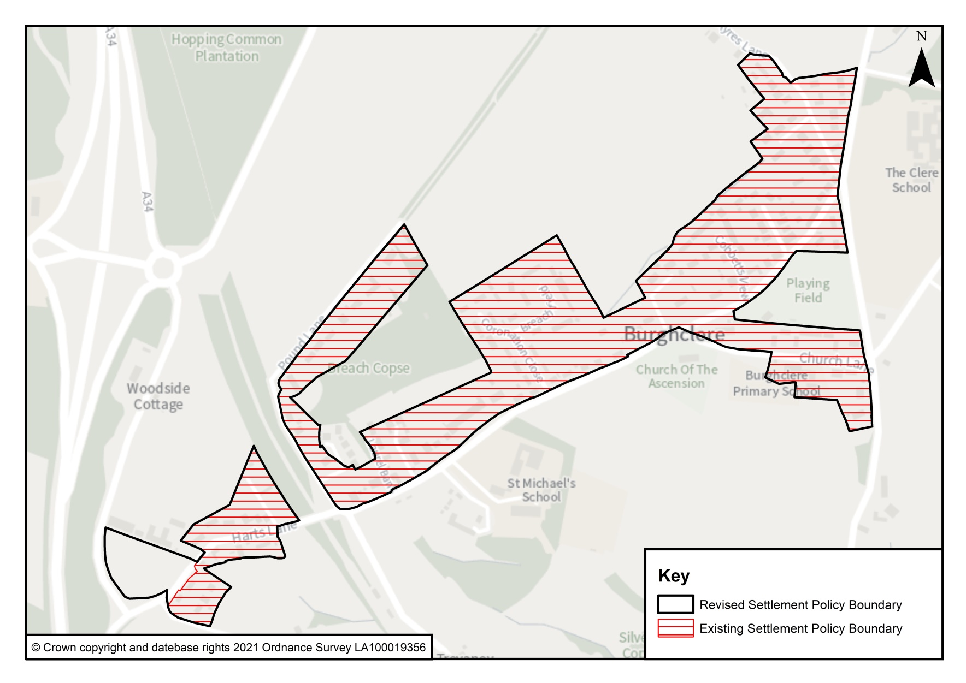

‘Major Development’ as defined by Footnote 55 of the NPPF.
PPG Paragraph: 041 ID:41-041-20140306.
National Design Guide paragraph 38.
Planning Policy Guidance on Climate Change, March 2019.

